Table of Contents

EXECUTIVE OVERVIEW 18

What PANÉTA Is 19

What PANÉTA Is Explicitly Not 19

Core Operating Principle 19

Strategic Positioning 20

What PANÉTA Does and Does NOT Do 20

1.PANÉTA Shall Never Hold Client Funds or Assets 21

Architectural Enforcement 21

UI Enforcement 21

2.Financial Execution Shall Occur at Licensed Institutions 22

Execution Flow Model 22

3 PANÉTA Shall Operate on a Read-Only or Instruction-Only Basis 22

🔵 Instruction Mode (Payments) 23

Read-Only Mode (Wealth) 23

4.All Access Shall Be Consent-Driven and Revocable 24

Consent Rules 24

Architectural Controls 24

UI Controls 24

5. Every Action Shall Be Auditable, Traceable, and Time-Stamped 24

Logged Events Include: 24

Audit Properties 25

6.Regulatory Oversight Shall Be Enabled by Design — Not Retrofitted 25

Regulator Capabilities 25

Regulator Restrictions 25

Architectural Guarantees 25

System-Level Enforcement Summary 26

Absolute Prohibition List 26

PANÉTA Development Methodology 26

Incremental, Domain-Driven Agile (Hybrid) 26

WHY THIS METHODOLOGY FITS PANÉTA 27

CORE PRINCIPLES (Side Panel in Diagram) 28

Domain-Driven Design (DDD) 28

Incremental Delivery 28

Agile Execution 28

PHASED DELIVERY MODEL (Main Diagram Flow) 28

PHASE 0 — Architecture & Compliance *(Start Here)* 28

PHASE 1 — Accounts Aggregation *(FOUNDATION)* 29

PHASE 2 Payments Orchestration 29

PHASE 3 FX Infrastructure 29

PHASE 4 Wealth & Investment Technology 29

PHASE 5 Institutional & Regulator Interfaces 30

TEAM SETUP (Small but Effective) 30

TECH STACK (Safe Defaults) 30

COMMON FAILURE TRAPS (Avoid These) 31

GOLDEN RULE 31

EXECUTIVE ONE-PARAGRAPH SUMMARY 31

4. Explicit Operating Boundaries 31

What PANÉTA Does and Does NOT Do 31

1️.PANÉTA Shall Never Hold Client Funds or Assets 32

Architectural Enforcement 32

UI Enforcement 32

2️.All Financial Execution Shall Occur at Licensed Institutions 33

Execution Flow Model 33

3️.PANÉTA Shall Operate on a Read-Only or Instruction-Only Basis 33

🔵 Instruction Mode (Payments) 34

Read-Only Mode (Wealth) 34

4️.All Access Shall Be Consent-Driven and Revocable 35

Consent Rules 35

Architectural Controls 35

UI Controls 35

5️.Every Action Shall Be Auditable, Traceable, and Time-Stamped 35

Logged Events Include: 35

Audit Properties 36

6️ .Regulatory Oversight Shall Be Enabled by Design — Not Retrofitted 36

Regulator Capabilities 36

Regulator Restrictions 36

Architectural Guarantees 36

System-Level Enforcement Summary 37

Absolute Prohibition List 37

PANÉTA Requirements & Flexibility Framework 37

1.FLEXIBILITY: How the System Can Evolve Without Breaking 38

What “Flexibility” Means for PANÉTA 38

How Flexibility Is Achieved (Architecturally) 38

2.STAGED DEVELOPMENT MODEL (WHY STAGES MATTER) 39

Correct Staging Logic 39

3.FUNCTIONAL REQUIREMENTS (WHAT THE SYSTEM MUST DO) 40

A. Accounts Aggregation – Functional Requirements 40

B. Payments Orchestration – Functional Requirements 40

C. FX Infrastructure – Functional Requirements 40

D. Wealth & Investment Technology – Functional Requirements 40

E. Compliance & Governance – Functional Requirements 41

4.NON-FUNCTIONAL REQUIREMENTS (HOW THE SYSTEM MUST BEHAVE) 41

A. Security Requirements 41

B. Performance Requirements 41

C. Scalability Requirements 41

D. Reliability & Availability 42

E. Auditability & Traceability 42

F. Compliance & Regulatory 42

G. Usability 42

5.FLEXIBILITY + REQUIREMENTS WORKING TOGETHER 42

Example: Adding a New Country 42

Example: Adding Crypto Assets (Read-Only) 43

6.SIMPLE CHECKLIST FOR DEVELOPERS 43

7.ONE-LINE EXECUTIVE SUMMARY 43

Individual / Business – Local or Global Payment 43

3. Integration Layer 44

Backend 44

2.Where USSD Fits in Your System 44

Database 44

Security 45

System Architecture 45

PANÉTA System Architecture — Summary 45

1️. Purpose of the Architecture 45

2.High-Level Structure (Layered Design) 46

Presentation Layer 46

PANÉTA Core Orchestration Layer 46

External APIs Layer 47

Financial Institutions Layer 47

Licensed Execution Layer 47

3.Security, Compliance & Oversight (Cross-Cutting Controls) 48

4.What PANÉTA Is and Is Not 48

PANÉTA IS 48

PANÉTA IS NOT 48

PANÉTA Deployment Diagram 50

1.High-Level Meaning (One Sentence) 50

2.Cloud & Infrastructure Layer (Top) 50

AWS / Cloud Environment 50

3.External Clients Layer (Left Side) 50

Users, Businesses & Institutions 50

4.API Gateway (Entry Point) 51

API Gateway 51

5.PANÉTA Core — Dual Engine Architecture (Centre) 51

A. Payments Orchestration Engine (Zero-Custody) 52

B. Wealth Management Technology Engine 52

6.Secure Storage Layer (Shared by Both Engines) 53

Databases & Vaults 53

7.Licensed Execution Layer (Bottom) 53

Financial Institutions (External) 53

8.Third-Party Providers Layer (Right Side) 54

External Services 54

9.Regulatory Oversight Layer (Overlay Across System) 54

Regulators & Supervisors 54

How Flows Work (Deployment View) 55

Payment Flow 55

Wealth Flow 55

Why This Deployment Is Powerful 55

PANÉTA Profile Diagram 57

1.What a “Profile Diagram” Means Here 57

2.Top Layer — User Profiles 57

Individuals 57

Businesses 58

Advisors (Optional, Read-Only) 58

3.Entry & Security Layer 59

API Gateway & Secure Storage 59

4.PANÉTA Core — Dual Engine Access 59

5.Payments Orchestration Engine (Zero-Custody) 59

What Profiles Can Do 59

What the Engine Does 59

6.Wealth Management Technology Engine 60

What Profiles Can Do 60

What the Engine Does 60

7.Flow Separation (Critical Concept) 60

Instruction Flow (Payments) 60

Read-Only Data Flow (Wealth) 60

8.Execution & Aggregation Layers 61

Execution Layers (Payments) 61

Aggregation Layers (Wealth) 61

9.Regulator Profile 61

Regulators 61

PANÉTA Sequence Diagram 64

1.Purpose of the Diagram (What it proves) 64

2.Actors (Top of the Diagram) 64

Individual 64

Business 64

Advisor (Read-Only) 64

Regulators 64

AWS / API Gateway 65

3.Entry & Consent Phase (Steps 1–5) 65

1. Initiate / Accept Payment 65

2. Sign & Consent 65

3. View Aggregated Wealth (Optional Path) 65

4. Authenticate 65

5. Validate & Verify 65

4.Payments Instruction Phase (Steps 6–8) 65

6. Issue Payment Instruction 65

7. Run Compliance Checks 66

8. Generate Instruction 66

5.Licensed Execution Phase (Steps 9–11) 66

9. Execute Instruction (Debit / Credit) 66

10. Settle Payment / FX / Card 66

11. Return Settlement Status 66

6.Audit, Logging & Oversight (Steps 12–13) 66

12. Log Immutable Outcomes 66

13. Consume Data Log 67

7.User & Advisor Visibility (Steps 13–16) 67

13–16. View Transaction & Wealth Status 67

8.Bottom Layers Explained 67

Execution Layers 67

Aggregation Layers 67

9.Flow Legend (Very Important) Blue Arrows — Zero-Custody Instructions 68

Yellow Dashed Arrows — Read-Only Information 68

Why This Sequence Is Strong 68

PANÉTA Aggregation Flow — Expanded Developer View 70

Actors (What each component actually does) 70

User 70

PANÉTA (Internal Services) 70

Financial Institutions (External) 70

Stage-by-Stage Expanded Flow 70

Stage 1: User Onboarding (Internal) 70

What happens 70

Developer takeaway 71

Stage 2: Account Aggregation Initiation (Internal) 71

What happens 71

Developer takeaway 71

Stage 3: Consent & Authorisation (Internal → External) 71

What happens 71

Developer takeaway 72

Stage 4: Consent Granting (External) 72

What happens 72

Developer takeaway 72

Stage 5: Token Handling & Storage (Internal) 72

What happens 72

Developer takeaway 73

Stage 6: Initial Data Fetch (Internal → External) 73

What happens 73

Developer takeaway 73

Stage 7: Data Normalisation (Internal) 73

What happens 73

Developer takeaway 74

Stage 8: User Dashboard Presentation (Internal) 74

What happens 74

Critical rule 74

Developer takeaway 74

Stage 9: Continuous Data Refresh (Internal) 75

What happens 75

Developer takeaway 75

Stage 10: Consent Management (Internal) 75

What happens 75

Developer takeaway 75

Stage 11: Exception & Failure Handling (Internal) 76

Scenarios 76

Developer takeaway 76

Stage 12: Audit & Regulatory Visibility (Internal) 76

What is logged 76

Developer takeaway 76

One-Line Mental Model for Developers 76

PANÉTA Aggregation & Payments ERD — Explained 78

1What this ERD represents (big picture) 78

2Actors → Where they appear in the ERD 78

User 78

PANÉTA (Internal Systems) 78

Financial Institutions (External) 79

3Core ERD Entities (What each one means) 79

Users 79

User_Consent 80

Payment Requests 80

Payment Instruction 81

Compliance Checks 81

Destination Route 81

Payment Corridor 82

Pricing_Fee 82

Execution Log 82

Settlement Metadata 83

Access Tokens 83

4.How this ERD maps to your 12 stages 83

5.Why this ERD is Zero-Custody by design 84

6.Mental model (easy to remember) 84

7.Final one-line summary 84

PANÉTA — Send Money (Local / Same Currency) 86

Sequence Diagram Explained (Developer-Friendly) 86

1.What this diagram shows (big picture) 86

2.Actors (swimlanes in the diagram) 86

User 86

PANÉTA (Internal) 86

Issuer (Source) 86

Acquirer (Destination) 86

3.Stage-by-Stage Explanation 87

Stage 1 – User Initiation (Internal) 87

Stage 2 – Destination Definition (Internal) 87

Stage 3 – Transaction Intent Creation (Internal) 88

Stage 4 – Pre-Execution Controls (Internal) 88

4.1 Issuer Capability Check 88

4.2 Compliance & Risk 88

4.3 Fees & Summary 88

Stage 5 – Payment Instruction Generation (Internal) 89

Stage 6 – Issuer Execution (External) 89

Stage 7 – Settlement to Acquirer (External) 90

Stage 8 – Confirmation & Callbacks (External → Internal) 90

Stage 9 – PANÉTA Post-Execution Handling (Internal) 91

Stage 10 – Audit, Logging & Regulatory Visibility (Internal) 91

4.Mental model for developers (easy to remember) 91

5.One-line summary 92

PANÉTA — Payment Request / Receive Money 94

Sequence Diagram Explained (Developer-Friendly) 94

1What this flow is (big picture) 94

2Actors (swimlanes in the diagram) 94

Requesting User (Payee) 94

PANÉTA (Internal) 94

Paying User (Payer) 94

Issuer (External – Source) 95

Acquirer (External – Destination) 95

3Stage-by-Stage Explanation 95

Stage 1 – Payment Request Creation (Internal) 95

Stage 2 – Payment Request Object Creation (Internal) 95

Stage 3 – Request Presentation (Internal) 96

Stage 4 – Payer Opens Payment Request (Internal) 96

Stage 5 – Payer Selects Issuer (Internal) 97

Stage 6 – Pre-Execution Controls (Internal) 97

6.1 Funding Readiness 97

6.2 Compliance & Risk 97

6.3 Fees & Confirmation 97

Stage 7 – Payment Instruction Generation (Internal) 98

Stage 8 – Issuer Execution (External) 98

Stage 9 – Settlement to Acquirer (External) 98

Stage 10 – Confirmations (External → Internal) 99

Stage 11 – Request Finalisation (Internal) 99

Stage 12 – Audit & Regulatory Visibility (Internal) 99

4Mental model for developers 100

5One-line summary 100

PANÉTA Payments ERD — How “Send Money” Fits 102

Big picture (one paragraph) 102

ERD Sections (What each part is responsible for) 102

Page 1 — Intent, Instruction & Compliance 102

Page 2 — Routing, Pricing & Execution 102

Step-by-Step: Send Money → ERD Mapping 102

Stage 1: User Initiation 102

Stage 2: Destination Definition 103

Stage 3: Transaction Intent Creation 103

Stage 4: Pre-Execution Controls 104

Stage 5: Payment Instruction Generation 104

Stage 6: Issuer Execution 105

Stage 7: Settlement to Acquirer 105

Stage 8: Confirmations 106

Stage 9: Post-Execution Handling 106

Stage 10: Audit & Regulatory Visibility 106

Visual Mental Model (ERD Flow) 107

Why this ERD proves Zero-Custody 107

One-line developer summary 107

PANÉTA — Send Money 108

Cross-Border with FX Auto-Conversion 108

Sequence Diagram Explained (Developer View) 108

1What this diagram represents (big picture) 108

2Actors (swimlanes in the diagram) 109

User 109

PANÉTA (Internal) 109

Issuer (External – Source) 109

FX Provider(s) (External) 109

Acquirer (External – Destination) 109

3Stage-by-Stage Explanation 110

Stage 1 – User Initiation (Internal) 110

Stage 2 – Destination Definition (Internal) 110

Stage 3 – Transaction Intent Creation (Internal) 110

Stage 4 – Pre-Execution Controls (Internal) 111

4.1 Issuer Capability Check 111

4.2 Compliance & Regulatory Screening 111

Stage 5 – FX Auto-Conversion Discovery (Internal) 112

Stage 6 – User FX Confirmation (Internal) 112

Stage 7 – Payment & FX Instruction Generation (Internal) 113

Leg A – Debit & FX 113

Leg B – Credit Destination 113

Stage 8 – Issuer Execution (External) 113

Stage 9 – FX Execution (External) 113

Stage 10 – Settlement to Acquirer (External) 114

Stage 11 – Confirmations & Callbacks 114

Stage 12 – PANÉTA Post-Execution Handling (Internal) 114

Stage 13 – Audit & Regulatory Visibility (Internal) 115

4Mental model for developers 115

5One-line summary 115

PANÉTA — Merchant Payments (SoftPOS) 117

End-to-End Orchestration Model (Explained) 117

1 What this diagram represents (big picture) 117

2Foundational principles (why the design looks this way) 117

3 Actors (the vertical lanes in the diagram) 117

Merchant (Payee) 117

PANÉTA (Internal) 117

Customer (Payer) 118

Issuer (External – Source) 118

Acquirer (External – Destination) 118

4PART A — Local / Same-Currency SoftPOS Flow 118

Stage 1: Merchant Payment Initiation (Internal) 118

Stage 2: Payment Request Object Creation (Internal) 118

Stage 3: Customer Presentation (Internal) 119

Stage 4: Customer Selects Issuer (Internal) 119

Stage 5: Pre-Execution Controls (Internal) 120

5.1 Funding Readiness 120

5.2 Compliance & Risk 120

5.3 Fees & Confirmation 120

Stage 6: Payment Instruction (Internal) 120

Stage 7: Issuer Execution (External) 121

Stage 8: Settlement to Acquirer (External) 121

Stage 9: Confirmation & Completion (Internal) 121

5PART B — Cross-Border / FX SoftPOS (What changes) 122

6Mental model for developers 122

7One-line summary 122

PANÉTA — P2P FX Exchange 124

Smart Escrow Orchestration (Explained Simply) 124

1What this diagram represents (in plain terms) 124

2Core principle (why “Smart Escrow”) 124

Traditional Escrow 124

PANÉTA Smart Escrow 124

3️Actors in the diagram 125

FX Initiator (User A) 125

FX Counterparty (User B) 125

PANÉTA (Internal) 125

Issuers (External) 125

Acquirers (External) 125

4Stage-by-Stage Explanation 125

Stage 1 — FX Offer Creation 125

Stage 2 — Offer Discovery & Matching 126

Stage 3 — Smart Escrow Preconditions 126

Issuer readiness checks (both users) 126

Compliance checks 126

Stage 4 — Logical Escrow Activation 127

Stage 5 — Atomic FX Instruction Creation 127

Leg A 127

Leg B 127

Stage 6 — Execution Phase (External) 128

Stage 7 — Settlement & Credit 128

Stage 8 — Confirmation & Escrow Release 128

Stage 9 — Failure & Safety Handling 128

Partial failure prevention 128

Timeout handling 128

Disputes 129

Stage 10 — Audit & Regulatory Visibility 129

5Developer mental model (easy to remember) 129

6One-line summary 130

PANÉTA — Wealth Management Technology 132

Zero-Custody • Read-Only • Decision-Support (Explained) 132

2Core principles (why the diagram looks like this) 132

3Actors (swimlanes in the diagram) 132

User (All Tiers) 132

PANÉTA (Internal Engines) 132

External Asset Platforms 133

4End-to-End Flow Explained 133

Stage 1 — User Onboarding & Eligibility 133

Stage 2 — Asset Aggregation Initiation 133

Stage 3 — Consent & Authorisation 134

Stage 4 — Token Handling & Security(we can have a call over this ) 134

Stage 5 — Initial Asset Data Ingestion 134

Stage 6 — Data Normalisation & Classification 134

Stage 7 — Dashboard Generation (Tier-Aware) 135

Silver (Retail, Free) 135

Gold (Professionals) 135

Platinum (Asset Managers) 135

Diamond (Institutions) 135

Stage 8 — Valuation & Performance Analytics 136

Stage 9 — Risk & Exposure Analysis 136

Stage 10 — Scenario & What-If Modelling 136

Stage 11 — Insights & Decision Support 136

Stage 12 — User Action Pathways 137

Stage 13 — Continuous Data Refresh 137

Stage 14 — Consent & Access Management 137

Stage 15 — Subscription & Entitlement Enforcement 137

Stage 16 — Audit & Regulatory Visibility 137

5Developer mental model (simple) 138

6 One-line summary 138

PANÉTA — Peer-to-Global FX Marketplace 140

1WHO ARE THE LANES (Swimlanes at the Top) 140

FX Initiator (Peer / Client) 140

PANÉTA (Global FX Marketplace Engine) 140

Issuer (External – Source of Funds) 140

Global FX Liquidity Providers (External) 140

Acquirer (External – Destination) 140

2CORE PRINCIPLE (The Yellow Box at the Top) 140

3STAGE-BY-STAGE FLOW 141

Stage 1 — FX Intent Initiation 141

Stage 2 — FX Market Order Object Creation 142

Stage 3 — Global Liquidity Discovery 142

Stage 4 — Liquidity Response & Normalisation 143

🔹 Stage 5 — Price Discovery & Best Execution 143

If large order: 143

If standard order: 143

🔹 Stage 6 — User Quote Review & Confirmation 144

🔹 Stage 7 — Pre-Execution Controls 144

Stage 8 — Composite FX Instruction Generation 145

Leg A — Debit & FX 145

Leg B — Credit 145

Stage 9 — Issuer Debit (External) 145

Stage 10 — Global FX Execution (External) 145

Stage 11 — Settlement to Acquirer 146

Stage 12 — Confirmation & Reconciliation 146

Stage 13 — Audit & Regulatory Visibility 147

PANÉTA Payments ERD 149

PAGE 1 OF 2 CORE PAYMENT INSTRUCTION MODEL 149

1️Users 149

2️User_Consent 149

3️Payment_Request 150

4️Payment_Instruction 150

5️Compliance_Checks 150

Page 1 Summary 151

PAGE 2 OF 2 ROUTING, EXECUTION & PRICING 151

6️Destination_Route 151

7️ Payment_Corridor 151

8️ Execution_Log 152

9️ Settlement_Metadata 152

10 Pricing_Fee (0.99% Revenue Model) 152

Page 2 Summary 153

Zero-Custody Guarantee (Proven by the ERD) 153

PANÉTA Wealth ERD 155

What this ERD is for 155

Core Design Guarantees (Why it’s “Advisor-Safe”) 155

Entities (Top → Bottom) 155

1️Wealth_Account 155

2️.Account_Holding 156

3️.Wealth_Analytics 156

4️.Wealth_Report 157

5️.Advisor_Access 157

How Data Flows (Read-Only) 158

What’s Intentionally NOT in This ERD 158

Regulatory & Legal Implications 158

PANÉTA – Developer & Architecture Completion Document 160

1. Purpose of This Document 160

2. Service Boundary Definitions (Microservices) 160

3. API Contracts (Interfaces) 160

4. State Machines & Lifecycle Management 160

5. Event Model (Event-Driven Architecture) 161

6. Fee Model Rules (0.99%) 161

7. Non-Functional & Regulatory Constraints 161

8. Developer Build Order (Runbook) 161

9. Conclusion 161

With this document added to the existing architecture, diagrams, and ERDs, PANÉTA becomes fully implementable by a competent development team while maintaining strict zero-custody, regulatory safety, and architectural clarity 161

Developer hand-off artifacts 162

Service Boundaries (Microservice Map) 163

Auth & Identity Service 163

2. Consent & Access Service 163

3. Payments Orchestration Service 163

4. Compliance Service 164

5. Routing & Corridor Service 164

6. Execution Adapter Service 164

7. Pricing & Fee Service (0.99%) 165

8. Wealth Aggregation Service (Read-Only) 165

9. Wealth Analytics Service 165

Audit & Logging Service 166

5.How Services Talk to Each Other 166

6.Microservice Map 167

7 One-Sentence 167

API Contracts (Request / Response Definitions) 168

Why This Matters 168

Core Payments API Endpoints 169

Core Wealth (Read-Only) API Endpoints 170

Required Elements of Every API Contract 170

Impact on Implementation Consistency 171

Summary 171

3. State Machines (CRITICAL) 172

Payment_Request State Machine 173

Payment_Instruction State Machine 174

Execution State Machine 174

Benefits of Explicit State Machines 175

4. Event Model (Async Backbone) 175

Canonical Event List 175

Event Definitions (Conceptual) 175

5. Fee Application Rule (0.99%) — Formalized 176

Why This Matters 176

Fee Design Principle 177

Explicit Fee Rules (Mandatory) 177

Explicit Prohibitions (Must NOT Happen) 178

Relationship to Zero-Custody Model 179

Audit and Regulatory Implications 179

Summary 179

6. Non-Functional Constraints (Guardrails) 180

What Is Missing 180

Why This Matters 180

Purpose of Non-Functional Constraints 180

Mandatory Guardrails (MUST / MUST NOT) 181

PANÉTA MUST NOT 181

PANÉTA MUST 181

Enforcement in Development and Reviews 182

Regulatory and Audit Implications 182

Summary 182

7. Developer Runbook (How to Start) 183

Why This Matters 183

Required Developer Build Order 184

1. Auth & Consent Service 184

2. Payment Request → Instruction Flow 184

3. Compliance Checks 185

4. Execution Adapters (Mock First) 185

5. Audit Logging 185

6. Fee Service (0.99%) 186

7. Wealth Aggregation (Read-Only) 186

Development Principles Enforced by This Runbook 187

Use of This Runbook 187

Summary 187

# 

# EXECUTIVE OVERVIEW

PANÉTA Capital (Private) Limited is a financial technology and infrastructure company operating a **neutral, cloud-native, zero-custody orchestration layer** for global finance.

PANÉTA does not participate in the movement, custody, or ownership of funds or assets. Instead, it provides a secure orchestration and intelligence layer that connects licensed financial institutions, payment rails, FX providers, brokers, and custodians into a unified, interoperable financial network.

Its core function is coordination — not execution.

## What PANÉTA Is

PANÉTA is:

* A **financial orchestration platform**
* A **compliance-first infrastructure layer**
* A **neutral routing and coordination engine**
* A **consent-driven aggregation and instruction system**
* A **regulator-aligned technology framework**

PANÉTA enables:

* Secure payment instruction routing
* Cross-border corridor coordination
* FX price discovery and orchestration
* Read-only wealth aggregation
* Portfolio analytics and exposure visibility
* Immutable audit logging
* Built-in regulatory oversight access

It serves individuals, businesses, platforms, institutions, and regulators — without assuming custodial or execution risk.

## What PANÉTA Is Explicitly Not

PANÉTA is **not**:

* A bank
* A wallet
* A custodian of funds or assets
* A payment processor acting as principal
* An FX dealer or market maker
* An investment adviser or broker

All financial execution occurs exclusively at licensed institutions operating under their respective regulatory frameworks.

## Core Operating Principle

PANÉTA connects, coordinates, and orchestrates existing licensed financial institutions, platforms, and rails into a single interoperable financial network — while preserving strict regulatory boundaries and institutional roles.

It operates under six non-negotiable constraints:

1. Never holds client funds or assets
2. Never executes financial transactions internally
3. Operates on instruction-only (payments) or read-only (wealth) modes
4. Requires explicit, revocable consent for all access
5. Logs every action immutably and time-stamped
6. Enables regulatory oversight by design

## Strategic Positioning

PANÉTA functions as a **control tower for financial infrastructure**, not as a financial intermediary.

Licensed institutions:

* Hold funds
* Execute payments
* Convert currencies
* Custody assets
* Maintain ledgers

PANÉTA:

* Validates intent
* Applies compliance controls
* Routes instructions
* Aggregates visibility
* Audits outcomes
* Provides analytical insight

This separation eliminates custody risk, reduces systemic exposure, and strengthens regulatory clarity

### ****What PANÉTA Does and Does NOT Do****

(Non-Negotiable Operating Constraints — Enforced by Architecture, Process, and UI)

This section formalises the absolute constraints under which PANÉTA operates.  
These are not design preferences — they are structural guarantees embedded into the system architecture, ERDs, APIs, and compliance controls.

They apply across:

* All microservices
* All payment flows
* All wealth aggregation flows
* All UI surfaces
* All jurisdictions

They are **non-negotiable and system-enforced**.

## 1.PANÉTA Shall **Never Hold Client Funds or Assets**

**Definition**

PANÉTA shall not:

* Maintain wallets
* Maintain internal balances
* Maintain custodial accounts
* Hold securities
* Pool liquidity
* Temporarily settle funds
* Maintain omnibus accounts

Funds and assets are always held by:

* Licensed banks
* Licensed wallet operators
* Licensed brokers
* Licensed custodians
* Licensed FX providers

### Architectural Enforcement

* No “wallet” or “balance ledger” tables exist in the ERD
* No internal settlement engine
* No custody database schema
* No asset storage logic
* No pooled account model
* No escrow account owned by PANÉTA

### UI Enforcement

The UI never displays:

* “Available balance at PANÉTA”
* “PANÉTA wallet”
* “Transfer to PANÉTA”

All balances shown are explicitly labelled:

“Data sourced from [Institution Name] – Read Only”

## 2.Financial Execution Shall Occur at Licensed Institutions

**Definition**

All debits, credits, FX conversions, settlements, trades, and asset movements occur:

* Outside PANÉTA
* On licensed rails
* Under institutional regulatory supervision

### Execution Flow Model

User → PANÉTA (Instruction Only)  
 ↓  
Licensed Institution → Executes Debit/Credit  
 ↓  
Settlement Rail  
 ↓  
Receiving Institution → Credits Account

PANÉTA only:

* Generates instructions
* Routes instructions
* Logs outcomes
* Displays status

It never:

* Executes transactions
* Moves funds
* Converts currency internally
* Rebalances portfolios

## 3 PANÉTA Shall Operate on a Read-Only or Instruction-Only Basis

PANÉTA has exactly two modes of operation:

### 🔵 Instruction Mode (Payments)

Used for:

* Send Money
* Receive Money
* Merchant Payments
* FX Transfers

PANÉTA:

* Validates intent
* Runs compliance
* Generates a digitally signed instruction
* Routes it externally

Money moves externally.

### Read-Only Mode (Wealth)

Used for:

* Account aggregation
* Portfolio visibility
* Risk analysis
* Scenario modelling

PANÉTA:

* Fetches data via consent
* Normalises formats
* Performs analytics
* Displays insights

It does not:

* Trade
* Execute
* Modify
* Reallocate

## 4.All Access Shall Be Consent-Driven and Revocable

Access to financial data or execution capability requires:

* Explicit user consent
* Defined scope (what data / what permissions)
* Time limitation
* Jurisdiction validation

### Consent Rules

* No consent → No access
* Expired consent → Immediate stop
* Revoked consent → Immediate token invalidation
* Scope-limited tokens only

### Architectural Controls

* User_Consent entity governs access
* Tokens encrypted in hardware-backed vault
* Consent linked to institution and scope
* No silent token reuse
* Consent revocation logged immutably

### UI Controls

Users can:

* View linked institutions
* View active scopes
* Revoke at any time
* See expiry dates

No hidden permissions.

## 5. Every Action Shall Be Auditable, Traceable, and Time-Stamped

Auditability is built-in — not optional.

### Logged Events Include:

* User authentication
* Consent grants & revocations
* Payment intent creation
* Compliance decisions
* Instruction generation
* Issuer confirmation
* Acquirer confirmation
* Settlement metadata
* FX rate acceptance
* Token usage

### Audit Properties

* Immutable
* Time-stamped (UTC)
* Digitally signed
* Non-editable
* Regulator-readable (read-only)

No action in PANÉTA occurs without an audit record.

## 6.Regulatory Oversight Shall Be Enabled by Design — Not Retrofitted

Regulators are integrated into the architecture from day one.

### Regulator Capabilities

* Read-only dashboards
* Audit log access
* Corridor-level visibility
* Compliance rule inspection
* System health metrics

### Regulator Restrictions

* No execution rights
* No modification rights
* No fund access
* No override capability

### Architectural Guarantees

* Separate regulator profile
* Immutable log feeds
* Jurisdiction-aware data access
* Evidence export APIs

Regulatory oversight is structurally supported, not manually assembled.

# System-Level Enforcement Summary

|  |  |  |
| --- | --- | --- |
| **Constraint** | **Enforced In** | **Cannot Be Bypassed By** |
| No custody | ERD design | UI, API, or service logic |
| External execution only | Routing layer | Orchestration service |
| Instruction / Read-only modes | Dual engine separation | Feature flags |
| Consent-driven access | Consent service | Admin override |
| Immutable audit | Event log architecture | Database writes |
| Regulator visibility | Role-based access | Internal services |
|  |  |  |

# Absolute Prohibition List

PANÉTA MUST NOT:

* Open client accounts
* Store client funds
* Perform internal clearing
* Execute FX internally
* Trade securities
* Provide investment advice
* Modify institutional balances
* Store user credentials
* Pool liquidity
* Act as a settlement intermediary

If a feature proposal introduces any of the above, development must stop and redesign.

# PANÉTA Development Methodology

## Incremental, Domain-Driven Agile (Hybrid)

**Not Agile-only · Not Waterfall · Not Big-Bang**  
Domain-Driven, Incremental Delivery with Architecture First

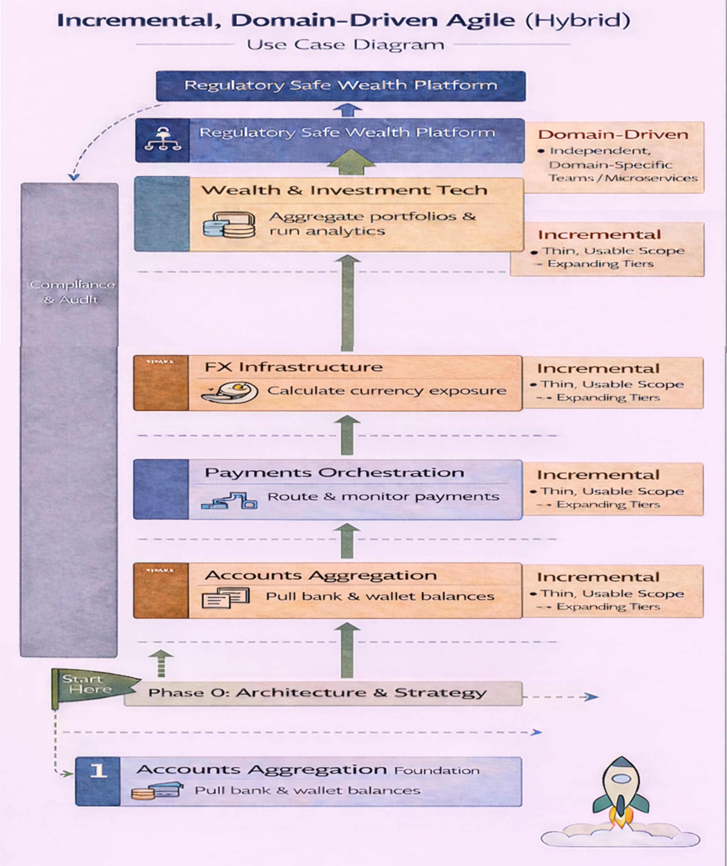

## 

## WHY THIS METHODOLOGY FITS PANÉTA

* Multiple regulated domains  
  (Aggregation, Payments, FX, Wealth)
* Strong compliance boundaries
* Independent microservices
* Long-term platform vision

## CORE PRINCIPLES (Side Panel in Diagram)

### Domain-Driven Design (DDD)

* Each domain:
  + Owns its data
  + Has its own language
  + Evolves independently  
    👉 Prevents cross-domain chaos

### Incremental Delivery

* Build a **thin, usable core**
* Expand **feature by feature**
* Every increment is **testable & compliant**

### Agile Execution

* 2–3 week sprints
* Agile **inside domains**
* Clear outcomes per sprint

## PHASED DELIVERY MODEL (Main Diagram Flow)

### PHASE 0 — Architecture & Compliance (Start Here)

**Foundation (2–3 weeks)**

* System architecture diagrams
* ERDs per domain
* Use cases & boundaries
* Domain glossary
* Compliance rules

**Key Decisions**

* Monorepo vs Polyrepo
* Event bus (Kafka / RabbitMQ)
* Auth (OAuth2)
* API style (REST-first)

**Do not skip this phase**

### PHASE 1 — Accounts Aggregation (FOUNDATION)

**Everything depends on this**

* User management
* Consent & disclosures
* Connect 1–2 banks / wallets
* Pull balances & transactions
* Normalise data
* Unified dashboard
* Audit logs

**Success:**  
User logs in → sees all accounts in one place

### PHASE 2 Payments Orchestration

**Built on Aggregation**

* Select source account
* Initiate payment request
* Route instruction to institution
* Receive confirmation
* Update aggregated balances

PANÉTA **does NOT execute payments**

### PHASE 3 FX Infrastructure

**Visibility → Price Discovery → Routing**

* RFQ engine
* Quote aggregation
* FX exposure calculation
* Settlement confirmation
* FX audit trails  
  (P2P FX later)

### PHASE 4 Wealth & Investment Technology

**Analytics Layer**

* Connect brokers
* Aggregate portfolios
* Valuation & performance
* Risk & exposure analytics
* Scenario modelling
* Tiered reporting

No advice · No execution · Read-only

### PHASE 5 Institutional & Regulator Interfaces

**Oversight & Scale**

* Regulator dashboards
* Audit exports
* Institutional APIs
* SLA & monitoring

## TEAM SETUP (Small but Effective)

* 1 Platform / Architecture Lead
* 1–2 Backend Engineers
* 1 Frontend Engineer
* 1 Compliance / Product Owner

**Sprint Rule**

* One domain
* One clear outcome

## TECH STACK (Safe Defaults)

**Backend**

* Spring Boot (core services)
* Laravel (admin / portals)
* REST APIs
* Event-driven messaging

**Data**

* PostgreSQL (core)
* Time-series DB (analytics later)

**Security**

* OAuth2
* Token-based access
* Encryption everywhere

## COMMON FAILURE TRAPS (Avoid These)

Analytics before data  
Mixing execution with visibility  
Ignoring compliance early  
Over-engineering microservices  
UI-first without backend discipline

## GOLDEN RULE

**If a feature increases custody risk, execution risk, or advisory risk — stop and redesign.**

## EXECUTIVE ONE-PARAGRAPH SUMMARY

PANÉTA should be developed using an incremental, domain-driven Agile methodology, beginning with Accounts Aggregation as the foundational visibility layer. Payments, FX, and Wealth capabilities are added progressively, ensuring regulatory safety, architectural clarity, and continuous user value without custody, execution, or advisory risk.

## 4. Explicit Operating Boundaries

### ****What PANÉTA Does and Does NOT Do****

(Non-Negotiable Operating Constraints — Enforced by Architecture, Process, and UI)

This section formalises the absolute constraints under which PANÉTA operates.  
These are not design preferences — they are structural guarantees embedded into the system architecture, ERDs, APIs, and compliance controls.

They apply across:

* All microservices
* All payment flows
* All wealth aggregation flows
* All UI surfaces
* All jurisdictions

They are **non-negotiable and system-enforced**.

## 1️.PANÉTA Shall **Never Hold Client Funds or Assets**

**Definition**

PANÉTA shall not:

* Maintain wallets
* Maintain internal balances
* Maintain custodial accounts
* Hold securities
* Pool liquidity
* Temporarily settle funds
* Maintain omnibus accounts

Funds and assets are always held by:

* Licensed banks
* Licensed wallet operators
* Licensed brokers
* Licensed custodians
* Licensed FX providers

### Architectural Enforcement

* No “wallet” or “balance ledger” tables exist in the ERD
* No internal settlement engine
* No custody database schema
* No asset storage logic
* No pooled account model
* No escrow account owned by PANÉTA

### UI Enforcement

The UI never displays:

* “Available balance at PANÉTA”
* “PANÉTA wallet”
* “Transfer to PANÉTA”

All balances shown are explicitly labelled:

“Data sourced from [Institution Name] – Read Only”

## 2️.All Financial Execution Shall Occur at Licensed Institutions

**Definition**

All debits, credits, FX conversions, settlements, trades, and asset movements occur:

* Outside PANÉTA
* On licensed rails
* Under institutional regulatory supervision

### Execution Flow Model

User → PANÉTA (Instruction Only)  
 ↓  
Licensed Institution → Executes Debit/Credit  
 ↓  
Settlement Rail  
 ↓  
Receiving Institution → Credits Account

PANÉTA only:

* Generates instructions
* Routes instructions
* Logs outcomes
* Displays status

It never:

* Executes transactions
* Moves funds
* Converts currency internally
* Rebalances portfolios

## 3️.PANÉTA Shall Operate on a Read-Only or Instruction-Only Basis

PANÉTA has exactly two modes of operation:

### 🔵 Instruction Mode (Payments)

Used for:

* Send Money
* Receive Money
* Merchant Payments
* FX Transfers

PANÉTA:

* Validates intent
* Runs compliance
* Generates a digitally signed instruction
* Routes it externally

Money moves externally.

### Read-Only Mode (Wealth)

Used for:

* Account aggregation
* Portfolio visibility
* Risk analysis
* Scenario modelling

PANÉTA:

* Fetches data via consent
* Normalises formats
* Performs analytics
* Displays insights

It does not:

* Trade
* Execute
* Modify
* Reallocate

## 4️.All Access Shall Be Consent-Driven and Revocable

Access to financial data or execution capability requires:

* Explicit user consent
* Defined scope (what data / what permissions)
* Time limitation
* Jurisdiction validation

### Consent Rules

* No consent → No access
* Expired consent → Immediate stop
* Revoked consent → Immediate token invalidation
* Scope-limited tokens only

### Architectural Controls

* User_Consent entity governs access
* Tokens encrypted in hardware-backed vault
* Consent linked to institution and scope
* No silent token reuse
* Consent revocation logged immutably

### UI Controls

Users can:

* View linked institutions
* View active scopes
* Revoke at any time
* See expiry dates

No hidden permissions.

## 5️.Every Action Shall Be Auditable, Traceable, and Time-Stamped

Auditability is built-in — not optional.

### Logged Events Include:

* User authentication
* Consent grants & revocations
* Payment intent creation
* Compliance decisions
* Instruction generation
* Issuer confirmation
* Acquirer confirmation
* Settlement metadata
* FX rate acceptance
* Token usage

### Audit Properties

* Immutable
* Time-stamped (UTC)
* Digitally signed
* Non-editable
* Regulator-readable (read-only)

No action in PANÉTA occurs without an audit record.

## 6️ .Regulatory Oversight Shall Be Enabled by Design — Not Retrofitted

Regulators are integrated into the architecture from day one.

### Regulator Capabilities

* Read-only dashboards
* Audit log access
* Corridor-level visibility
* Compliance rule inspection
* System health metrics

### Regulator Restrictions

* No execution rights
* No modification rights
* No fund access
* No override capability

### Architectural Guarantees

* Separate regulator profile
* Immutable log feeds
* Jurisdiction-aware data access
* Evidence export APIs

Regulatory oversight is structurally supported, not manually assembled.

# System-Level Enforcement Summary

| **Constraint** | **Enforced In** | **Cannot Be Bypassed By** |
| --- | --- | --- |
| No custody | ERD design | UI, API, or service logic |
| External execution only | Routing layer | Orchestration service |
| Instruction / Read-only modes | Dual engine separation | Feature flags |
| Consent-driven access | Consent service | Admin override |
| Immutable audit | Event log architecture | Database writes |
| Regulator visibility | Role-based access | Internal services |

# Absolute Prohibition List

PANÉTA MUST NOT:

* Open client accounts
* Store client funds
* Perform internal clearing
* Execute FX internally
* Trade securities
* Provide investment advice
* Modify institutional balances
* Store user credentials
* Pool liquidity
* Act as a settlement intermediary

If a feature proposal introduces any of the above, development must stop and redesign.

# PANÉTA Requirements & Flexibility Framework

(How to design, stage, and evolve the system safely)

## 1.FLEXIBILITY: How the System Can Evolve Without Breaking

### What “Flexibility” Means for PANÉTA

Flexibility means the system can:

* Add new institutions
* Add new asset classes
* Add new countries/jurisdictions
* Add new features (FX, Wealth, Payments)  
  **without rewriting core logic or breaking compliance**

### How Flexibility Is Achieved (Architecturally)

#### Domain Separation

Each domain is independent:

* Accounts Aggregation
* Payments Orchestration
* FX Infrastructure
* Wealth & Investment Technology
* Compliance & Audit

Changes in one domain **do not ripple across others**

#### Feature Gating

Features are enabled by:

* User type
* Jurisdiction
* Subscription tier
* Regulatory permission

Feature Enabled = true

IF jurisdiction == allowed

AND consent == valid

AND tier >= required

#### Connector-Based Integration

Banks, brokers, wallets are added via:

* Institution adapters
* Standard internal data models

New providers ≠ new system logic

#### Event-Driven Expansion

New services subscribe to events instead of tight coupling:

* BalanceUpdated
* PaymentConfirmed
* FXSettled
* PortfolioRecalculated

## 2.STAGED DEVELOPMENT MODEL (WHY STAGES MATTER)

PANÉTA is **too large** and **too regulated** for a single delivery.

### Correct Staging Logic

| **Stage** | **Focus** | **Why** |
| --- | --- | --- |
| Stage 0 | Architecture & compliance | Prevents redesign |
| Stage 1 | Accounts Aggregation | Data foundation |
| Stage 2 | Payments Orchestration | Execution routing |
| Stage 3 | FX Infrastructure | Pricing & exchange |
| Stage 4 | Wealth Technology | Analytics & insight |
| Stage 5 | Institutional & Regulators | Scale & oversight |

**Each stage adds capability, not risk**

## 3.FUNCTIONAL REQUIREMENTS (WHAT THE SYSTEM MUST DO)

Functional requirements describe **system behaviour**.

Below is a **clean, domain-aligned list**.

### A. Accounts Aggregation – Functional Requirements

* Allow users to connect bank, wallet, and card accounts
* Enforce explicit user consent before data access
* Retrieve balances and transactions (read-only)
* Normalise currencies and transaction formats
* Display unified account dashboard
* Allow users to revoke access at any time
* Log all access and refresh actions

### B. Payments Orchestration – Functional Requirements

* Allow users to select a source account
* Validate sufficient balance (via aggregation)
* Route payment instruction to institution
* Track payment status (pending, completed, failed)
* Display confirmations and receipts
* Enforce limits and jurisdiction rules

PANÉTA does **not** execute payments

### C. FX Infrastructure – Functional Requirements

* Allow users to request FX quotes (RFQ)
* Collect quotes from multiple providers
* Normalise and rank FX rates
* Display FX exposure from aggregated balances
* Route FX execution to selected provider
* Track settlement confirmations
* Record FX audit logs

### D. Wealth & Investment Technology – Functional Requirements

* Connect external brokers and custodians (read-only)
* Aggregate holdings into a unified portfolio
* Classify assets by type, sector, currency
* Calculate portfolio valuation
* Measure performance (TWR, IRR)
* Compute risk and exposure metrics
* Provide scenario (what-if) simulations
* Generate downloadable reports

### E. Compliance & Governance – Functional Requirements

* Enforce disclaimers and consent acceptance
* Apply jurisdiction-based feature restrictions
* Maintain immutable audit logs
* Provide regulator-facing views (read-only)

## 4.NON-FUNCTIONAL REQUIREMENTS (HOW THE SYSTEM MUST BEHAVE)

These are **just as important** as functional ones.

### A. Security Requirements

* OAuth2 / token-based authentication
* Encryption in transit and at rest
* Read-only access by default
* Immediate token revocation on consent withdrawal

### B. Performance Requirements

* Account refresh within defined SLAs
* Async processing for heavy analytics
* Graceful degradation if providers are slow

### C. Scalability Requirements

* Horizontal scaling per domain
* Independent scaling for analytics engines
* Ability to onboard new institutions without downtime

### D. Reliability & Availability

* Retry mechanisms for provider failures
* Idempotent API operations
* Event replay capability

### E. Auditability & Traceability

* All actions time-stamped
* User, system, and provider actions logged
* Logs retained per regulatory policy

### F. Compliance & Regulatory

* Jurisdiction-aware data handling
* Feature gating by law
* Clear separation of execution vs visibility

### G. Usability

* Single-pane-of-glass dashboard
* Clear disclaimers
* No hidden execution actions
* Transparent calculations

## 5.FLEXIBILITY + REQUIREMENTS WORKING TOGETHER

### Example: Adding a New Country

* No change to core logic
* Enable via:
  + Jurisdiction rules
  + Feature flags
  + Compliance configuration

### Example: Adding Crypto Assets (Read-Only)

* Extend asset classification
* Add connector
* Analytics engine reuses same logic

## 6.SIMPLE CHECKLIST FOR DEVELOPERS

Before implementing any feature, ask:

1. Is this functional or non-functional?
2. Which domain owns it?
3. Does it increase custody or advisory risk?
4. Is it jurisdiction-gated?
5. Is it consent-controlled?
6. Is it auditable?

## 7.ONE-LINE EXECUTIVE SUMMARY

PANÉTA’s flexibility is achieved through domain separation, staged delivery, and strict functional and non-functional requirements that ensure scalability, compliance, and long-term evolution without increasing custody, execution, or advisory risk.

### Individual / Business – Local or Global Payment

USSD will act as a **frontend channel** (like mobile app or web) for users who don’t have smartphones or internet.

**Users can via USSD:**

* Send money (EcoCash ↔ InnBucks ↔ Omari)
* Check balance
* View last transactions
* Get help/support

### 3. Integration Layer

Adapters:

* EcoCashAdapter
* InnBucksAdapter
* OmariAdapter
* Mukuru

(These connect via **ZimSwitch or Bank**, not directly)

### Backend

* **Spring Boot** (recommended for fintech)

## 2.Where USSD Fits in Your System

User Phone

↓

USSD Gateway (Bank or MNO)

↓

Your Backend (Spring Boot)

↓

Transaction Engine

↓

Licensed Bank API

↓

EcoCash | InnBucks | Omari

### Database

* MySQL

### Security

* HSM or secure key vault
* JWT + OAuth2
* Request signing

### System Architecture

## PANÉTA System Architecture — Summary

### 1️. Purpose of the Architecture

The PANÉTA System Architecture defines a **zero-custody financial orchestration platform** that **coordinates payments and financial instructions** across licensed institutions **without holding funds, balances, or assets**.

PANÉTA acts as an **instruction, routing, compliance, and visibility layer**, while **licensed institutions execute all financial movements**.

**PANÉTA is a zero-custody, API-driven financial orchestration platform that securely routes payment and financial instructions to licensed institutions, enforces compliance, and provides full auditability—without ever holding or moving money.**

## 2.High-Level Structure (Layered Design)

### Presentation Layer

* Users access PANÉTA via **Web, Mobile, and APIs**
* Supports:
  + Individuals
  + Businesses
  + Platforms
* Handles:
  + Payment initiation
  + Payment requests (QR / links)
  + Status tracking
  + Reporting

No direct interaction with banks or wallets by users.

### PANÉTA Core Orchestration Layer

This is the **heart of the system**.

Includes:

* **Identity & Consent Engine** – authentication and permissions
* **Compliance & Risk Engine** – AML, sanctions, limits
* **Payment Orchestration Engine** – instruction routing only
* **Institution Connector Layer** – secure connectivity to financial rails

Key rule:

**PANÉTA never touches money it issues instructions only.**

### External APIs Layer

Provides standardized, secure access to:

* Open Banking APIs
* Card Network APIs
* FX Provider APIs
* SoftPOS APIs

This layer ensures:

* Interoperability
* Scalability
* Jurisdictional compliance

### Financial Institutions Layer

All **actual execution happens here**:

* Banks
* Wallet operators
* Card issuers
* FX providers
* Digital asset platforms

Money flows:

Institution → Institution

Not through PANÉTA.

### Licensed Execution Layer

Confirms that:

* All debits, credits, settlements, FX conversions, and card processing
* Are executed **under existing licenses**
* According to regulatory rules

PANÉTA only:

* Receives execution status
* Logs outcomes
* Notifies users

## 3.Security, Compliance & Oversight (Cross-Cutting Controls)

Built into every layer:

* End-to-end encryption
* Token vault & secure key management
* AML / PEP / CTF screening
* Time-limited permission tokens
* Immutable audit logs
* Regulator read-only access

## 4.What PANÉTA Is and Is Not

### PANÉTA IS

* A payment orchestration platform
* A financial coordination layer
* A compliance-first system
* A regulator-friendly infrastructure

### PANÉTA IS NOT

* A bank
* A wallet
* A payment processor
* A custodian
* An FX dealer

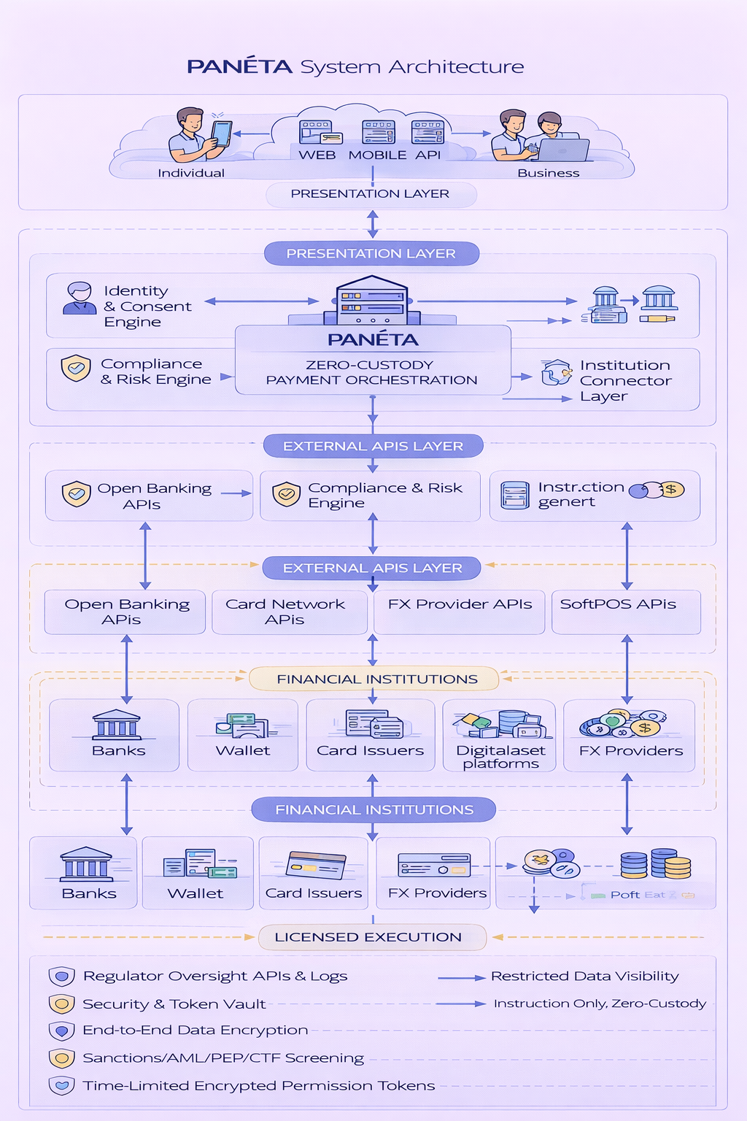

# PANÉTA Deployment Diagram

## 1.High-Level Meaning (One Sentence)

**The diagram shows how PANÉTA is deployed as a cloud-based financial orchestration and intelligence platform, where payments are executed by licensed institutions, wealth data is aggregated read-only, and regulators have full visibility — all without PANÉTA ever holding funds or assets.**

**PANÉTA is deployed as a secure, cloud-based financial orchestration and intelligence platform that routes payment instructions to licensed institutions, aggregates wealth data read-only, delivers decision-support analytics, and provides regulator-ready auditability—without ever holding money or assets.**

## 2.Cloud & Infrastructure Layer (Top)

### AWS / Cloud Environment

PANÉTA is deployed on a secure cloud platform (e.g. AWS), providing:

* High availability
* Regional scalability
* Fault tolerance
* Disaster recovery
* Network isolation & security controls

**PANÉTA does not deploy inside banks, brokers, or custodians** — it connects to them securely via APIs.

## 3.External Clients Layer (Left Side)

### Users, Businesses & Institutions

Includes:

* Individuals (mobile & web apps)
* Businesses & merchants (dashboards, SoftPOS)
* Enterprises & treasuries
* Advisors (view-only)
* Platforms integrating via APIs

They connect through:

* HTTPS
* API Gateway

They can:

* Initiate payments
* Request payments (QR / links)
* View transaction status
* View aggregated accounts & wealth
* Analyse portfolios & exposures
* Download reports

Users **never connect directly to banks, wallets, brokers, or FX providers** — PANÉTA abstracts complexity.

## 4.API Gateway (Entry Point)

### API Gateway

The **front door** for both **Payments** and **Wealth** services.

Responsibilities:

* Authentication & authorization
* Rate limiting
* Request validation
* Token verification
* Routing to internal services

Still **no business logic** — just secure traffic control.

## 5.PANÉTA Core — Dual Engine Architecture (Centre)

This is the **heart of PANÉTA**, composed of **two logically separated engines**:

### A. Payments Orchestration Engine (Zero-Custody)

Handles **movement of money by instruction only**.

Key components:

* **Identity & Consent Service**
* **Compliance & Risk Engine** (AML / PEP / sanctions)
* **Instruction Generator** (no funds attached)
* **Routing & Rail Selection Engine**
* **Audit Log Service**

PANÉTA **never debits, credits, or settles money**.

### B. Wealth Management Technology Engine

**(Zero-Custody · Read-Only · Decision-Support Only)**

This is **parallel**, not subordinate, to payments.

Key components:

* **Account & Asset Aggregation Engine**
* **Data Normalisation Engine**
* **Portfolio Intelligence Engine**
* **Risk & Exposure Analytics**
* **Forecasting & Scenario Engine**
* **Wealth Reporting Service**

What it does:

* Aggregates balances, assets, portfolios (read-only)
* Normalises currencies and asset classes
* Analyses risk, diversification, FX exposure
* Runs “what-if” simulations
* Produces insights & reports

What it does **NOT** do:

* No trading
* No rebalancing
* No execution
* No custody

**Execution always happens at licensed brokers, banks, or custodians — outside PANÉTA.**

## 6.Secure Storage Layer (Shared by Both Engines)

### Databases & Vaults

* **Audit & Event Log DB**
* **Consent Ledger**
* **Encrypted Token & Key Vault**
* **Normalised Data Store (read-only financial data)**

Security:

* Encrypted at rest
* Encrypted in transit
* Jurisdiction-aware storage
* Minimal metadata retention

**No customer balances, assets, or securities are stored as custody records.**

## 7.Licensed Execution Layer (Bottom)

### Financial Institutions (External)

Includes:

* Banks (issuers / acquirers)
* Wallet operators
* Card issuers
* FX providers
* Brokers & custodians
* Digital asset platforms

Money & assets move **only here**.

Examples:

Issuer Bank → Settlement Rail → Receiving Bank

Broker → Exchange → Custodian

PANÉTA is **not in the funds or asset flow**.

## 8.Third-Party Providers Layer (Right Side)

### External Services

* Wallet operators
* FX providers
* Card networks
* SoftPOS providers
* Investment platforms

They:

* Execute instructions (payments)
* Provide read-only data (wealth)
* Return status updates

PANÉTA:

* Tracks execution
* Logs outcomes
* Updates dashboards
* Notifies users

## 9.Regulatory Oversight Layer (Overlay Across System)

### Regulators & Supervisors

Regulators have:

* Read-only dashboards
* Audit logs
* Compliance evidence
* Aggregated system statistics

Restrictions:

* No execution rights
* No data modification

This **strengthens**, not weakens, regulatory oversight.

## How Flows Work (Deployment View)

### Payment Flow

User → API Gateway → Payments Orchestration

→ Compliance → Instruction → Licensed Institution

→ Settlement → Status → Audit → User

### Wealth Flow

User → API Gateway → Wealth Engine

→ Read-only Aggregation → Analytics

→ Insights & Reports → User

**No overlap between custody and intelligence.**

## Why This Deployment Is Powerful

|  |  |
| --- | --- |
| **Feature** | **Why it matters** |
| Zero custody | Eliminates systemic & fraud risk |
| Dual-engine design | Clear separation of money vs insight |
| Read-only wealth layer | No investment liability |
| Licensed execution | Regulatory compliance |
| Cloud-native | Scalable & resilient |
| Immutable logs | Full auditability |
| Clear legal boundaries | Institutional trust |

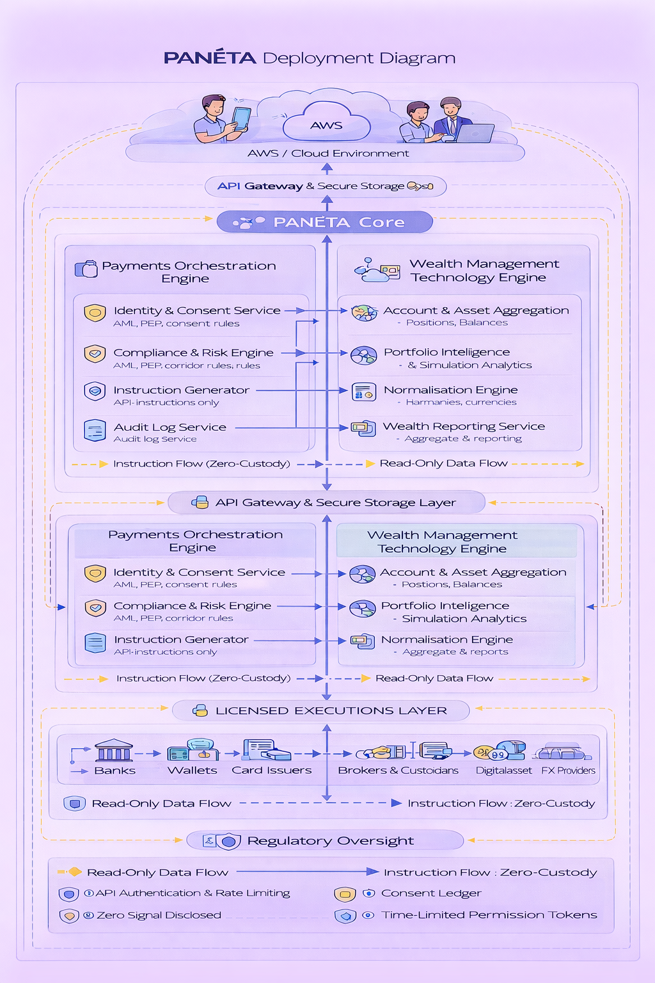

# PANÉTA Profile Diagram

## 1.What a “Profile Diagram” Means Here

**The PANÉTA Profile Diagram defines who can initiate instructions, who can view data, and who can execute transactions ensuring zero custody, read-only wealth visibility, strict role separation, and full regulatory oversight**

In PANÉTA, a **Profile Diagram** explains:

* **Who interacts with the platform**
* **What each profile is allowed to see or do**
* **Which engine (Payments or Wealth) they touch**
* **What data or instructions flow from each profile**
* **What is strictly forbidden (custody, execution, modification)**

It is about **roles, permissions, and boundaries**, not infrastructure.

## 2.Top Layer — User Profiles

### Individuals

Typical users:

* Consumers
* Entrepreneurs
* Professionals

They can:

* Initiate payments
* Request payments (QR / links)
* View transaction history
* View aggregated accounts & assets
* See wealth insights (read-only)

They **cannot**:

* Hold money in PANÉTA
* Execute trades
* Modify bank or investment balances

### Businesses

Includes:

* Merchants
* Enterprises
* Platforms

They can:

* Accept payments (SoftPOS / QR)
* Initiate payouts
* View cash flow & settlement status
* View aggregated financial position
* Download reports

They **cannot**:

* Custody funds
* Override compliance rules
* Bypass institutions

### Advisors (Optional, Read-Only)

Includes:

* Financial advisors
* Treasury advisors
* Portfolio managers

They can:

* View client-authorised aggregated data
* Analyse portfolios
* Generate insights & reports

They **cannot**:

* Initiate payments
* Execute investments
* Move funds or assets

Advisors are **decision-support only**.

## 3.Entry & Security Layer

### API Gateway & Secure Storage

All profiles enter PANÉTA through:

* Secure authentication
* Token-based access
* Time-limited permissions
* Explicit user consent

This layer:

* Enforces role-based access
* Prevents privilege escalation
* Logs every access

No profile bypasses this layer.

## 4.PANÉTA Core — Dual Engine Access

PANÉTA has **two engines**, and profiles interact with them **very differently**.

## 5.Payments Orchestration Engine (Zero-Custody)

### What Profiles Can Do

* Send money
* Receive money
* Accept payments
* Track transaction status

### What the Engine Does

* Identity & consent checks
* AML / PEP / sanctions screening
* Generates payment instructions
* Routes instructions to institutions
* Logs every step immutably

**Only instructions flow — never money.**

## 6.Wealth Management Technology Engine

**(Zero-Custody · Read-Only · Decision-Support Only)**

### What Profiles Can Do

* View aggregated accounts & assets
* Analyse portfolios
* See FX exposure
* Run “what-if” simulations
* Download reports

### What the Engine Does

* Aggregates data (read-only)
* Normalises currencies & asset classes
* Performs risk & scenario analysis
* Generates insights

**No execution, no trading, no custody.**

## 7.Flow Separation (Critical Concept)

The diagram clearly separates flows:

### Instruction Flow (Payments)

Profile → PANÉTA → Licensed Institution

* Used only for payments
* Zero-custody
* Logged and auditable

### Read-Only Data Flow (Wealth)

Licensed Institution → PANÉTA → Profile

* Data only
* No modification
* Consent-controlled

This separation is **intentional and enforced**.

## 8.Execution & Aggregation Layers

### Execution Layers (Payments)

* Banks
* Wallets
* Card issuers

They:

* Debit / credit
* Settle transactions
* Hold funds

PANÉTA does **not** execute.

### Aggregation Layers (Wealth)

* Banks
* Brokers
* Custodians
* FX providers
* Digital asset platforms

They:

* Hold assets
* Execute trades
* Maintain balances

PANÉTA only **reads and analyses**.

## 9.Regulator Profile

### Regulators

They have:

* Read-only access
* Audit logs
* Compliance evidence
* System-level views

They **cannot**:

* Execute transactions
* Modify data
* Access personal data without authority

This strengthens regulatory oversight.

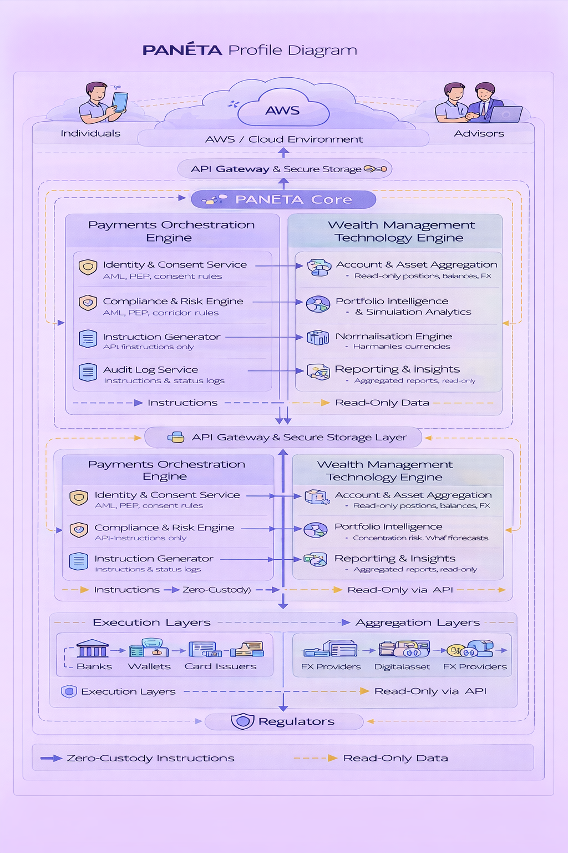

# PANÉTA Sequence Diagram

## 1.Purpose of the Diagram (What it proves)

This sequence diagram shows **how PANÉTA coordinates payments and wealth visibility** across users, businesses, advisors, institutions, and regulators **without ever holding money or assets**.

**The PANÉTA sequence diagram shows how users initiate intent, PANÉTA validates and orchestrates instructions, licensed institutions execute payments and settlements, wealth data is accessed read-only, and regulators observe everything — without PANÉTA ever holding money or assets**

It demonstrates:

* **Instruction vs execution separation**
* **Payments vs wealth data separation**
* **Who is responsible at each step**
* **Where money actually moves (and where it never does)**

## 2.Actors (Top of the Diagram)

### Individual

* Initiates payments
* Views transactions
* Views aggregated wealth (read-only)

### Business

* Accepts payments (QR / SoftPOS)
* Initiates payouts
* Views transaction & treasury data

### Advisor (Read-Only)

* Views authorised wealth data
* Analyses reports
* No execution rights

### Regulators

* Observe activity
* Access logs & compliance evidence
* No execution or modification rights

### AWS / API Gateway

* Secure entry point
* Authentication & routing only
* No business logic

## 3.Entry & Consent Phase (Steps 1–5)

### ****1. Initiate / Accept Payment****

* Individual or Business starts an action
* Could be send money, receive money, or accept payment

### ****2. Sign & Consent****

* User explicitly approves the action
* Consent scope is defined (payments or wealth)

### ****3. View Aggregated Wealth (Optional Path)****

* User or advisor requests wealth visibility
* This is **read-only** and separate from payments

### ****4. Authenticate****

* PANÉTA verifies identity via API Gateway
* MFA / tokens applied

### ****5. Validate & Verify****

* Consent rules checked
* Role permissions enforced

**No money or data moves yet**

## 4.Payments Instruction Phase (Steps 6–8)

### ****6. Issue Payment Instruction****

* PANÉTA converts user intent into an **instruction**
* No funds, balances, or assets attached

### ****7. Run Compliance Checks****

* AML / PEP / sanctions screening
* Corridor and jurisdiction rules

### ****8. Generate Instruction****

* Final instruction prepared
* Ready for licensed execution

PANÉTA is still **instruction-only**

## 5.Licensed Execution Phase (Steps 9–11)

### ****9. Execute Instruction (Debit / Credit)****

* **Banks / Wallets / Card Issuers** perform the action
* Actual debits and credits happen here

### ****10. Settle Payment / FX / Card****

* Settlement occurs on licensed rails
* FX conversion happens at licensed FX providers

**This is where money moves — outside PANÉTA**

### ****11. Return Settlement Status****

* Institutions send execution status back to PANÉTA
* Status only (no funds)

## 6.Audit, Logging & Oversight (Steps 12–13)

### ****12. Log Immutable Outcomes****

* PANÉTA writes:
  + Instruction
  + Status
  + Timestamps
* Logs are tamper-proof

### ****13. Consume Data Log****

* Logs feed dashboards
* Regulator access enabled (read-only)

This creates **full traceability without custody**

## 7.User & Advisor Visibility (Steps 13–16)

### ****13–16. View Transaction & Wealth Status****

* Individuals and Businesses:
  + View transaction outcomes
  + View settlement status
* Advisors:
  + View authorised wealth data
* All views are **read-only**

PANÉTA presents **information**, not assets.

## 8.Bottom Layers Explained

### Execution Layers

* Banks
* Wallet operators
* Card issuers

Handle **money movement**

### Aggregation Layers

* FX providers
* Digital asset platforms
* Investment platforms

Provide **read-only data**

## 9.Flow Legend (Very Important) Blue Arrows — Zero-Custody Instructions

* PANÉTA → Institutions
* Used for payments only
* No money flows through PANÉTA

### Yellow Dashed Arrows — Read-Only Information

* Institutions → PANÉTA → Users / Advisors / Regulators
* Used for wealth & reporting
* No modification allowed

## Why This Sequence Is Strong

* Proves PANÉTA is **not a bank**
* Proves PANÉTA is **not a wallet**
* Proves PANÉTA is **not an investment platform**
* Shows **clear legal responsibility**
* Makes regulatory oversight simple
* Scales across payment rails and asset types

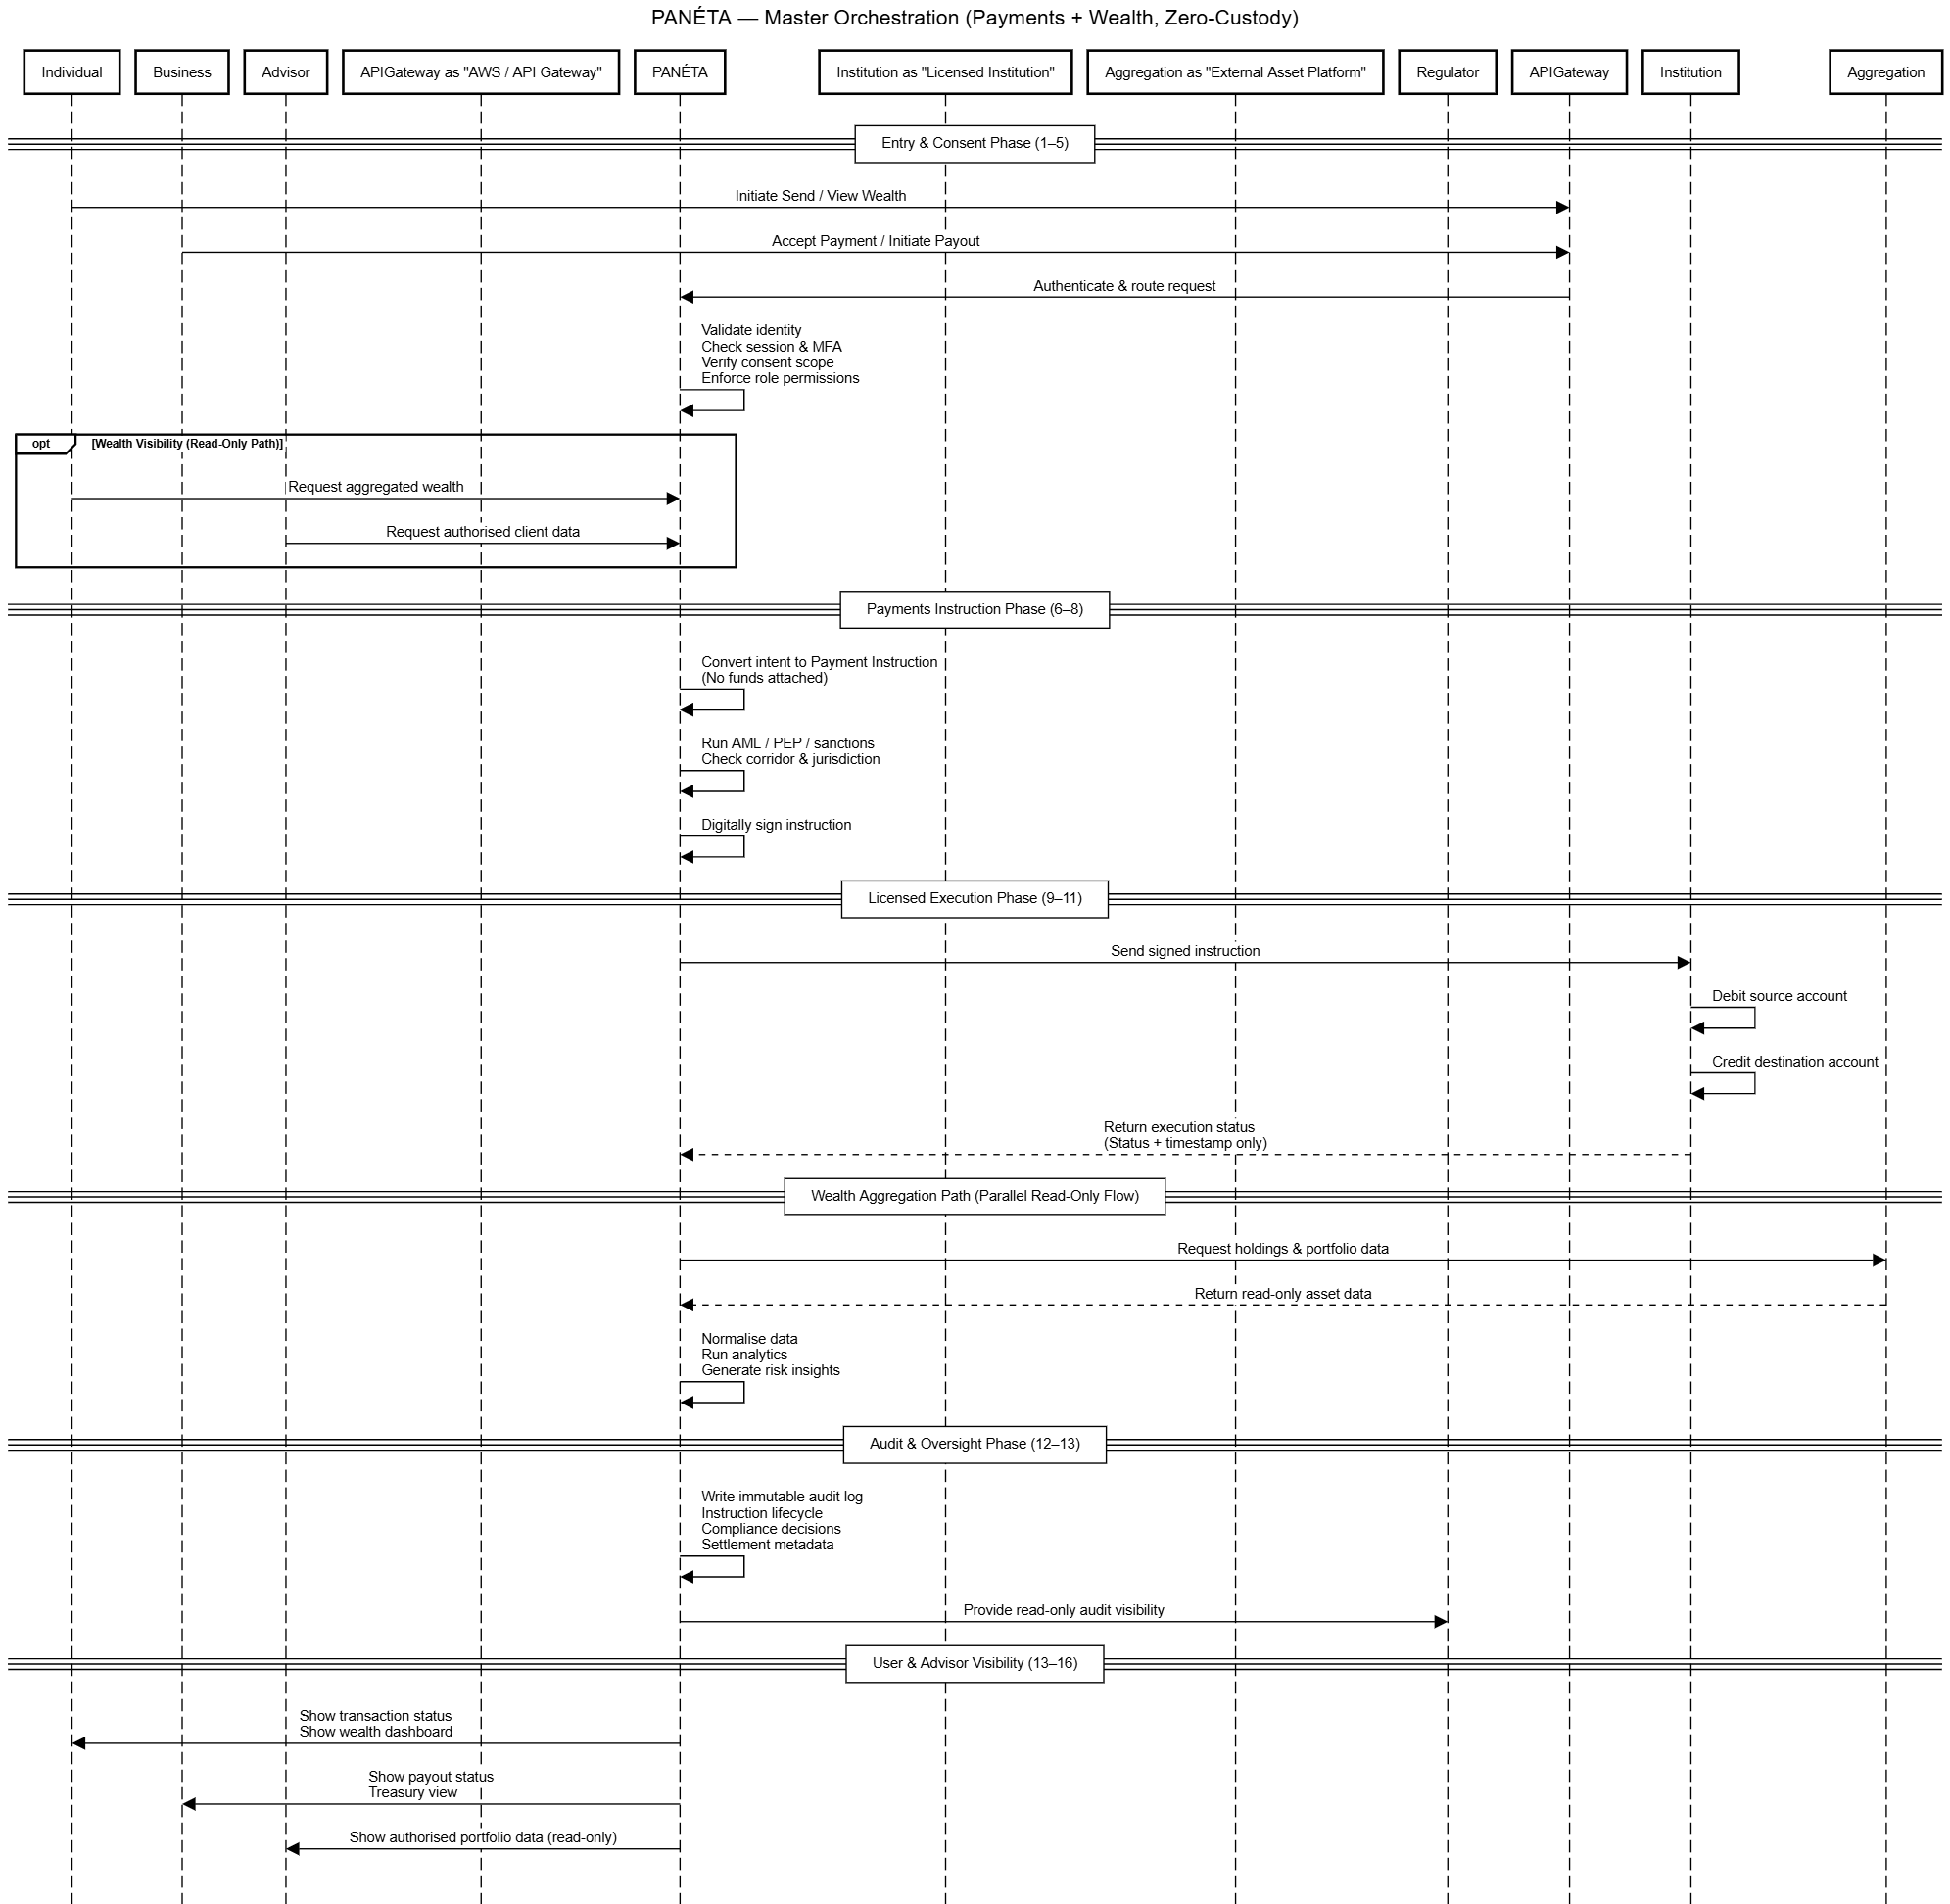

# PANÉTA Aggregation Flow — Expanded Developer View

This system is a **read-only financial data aggregation platform**.  
PANÉTA **never holds funds, credentials, or executes transactions**.  
It orchestrates consent, token usage, and data visibility only.

## Actors (What each component actually does)

### ****User****

* Individual or business user
* Wants a **single dashboard** showing accounts from many institutions

### ****PANÉTA (Internal Services)****

* **Aggregation UI** – user-facing screens (onboarding, link accounts, dashboard)
* **Identity & Consent Engine** – manages identity, consent lifecycle, risk tier
* **Institution Connector Layer** – talks to banks/wallets via APIs/OAuth
* **Data Normalisation Engine** – cleans and standardises raw data
* **Security & Token Vault** – encrypts and stores access tokens
* **Audit & Regulatory Layer** – immutable logs for compliance

### ****Financial Institutions (External)****

* Banks, wallets, card issuers, digital asset platforms
* **They hold the real accounts, balances, and transactions**

## Stage-by-Stage Expanded Flow

## **Stage 1: User Onboarding (Internal)**

### What happens

1. User signs up on PANÉTA
2. PANÉTA:
   * Creates an internal user identity
   * Opens a secure session
   * Evaluates device, IP, and security posture
3. PANÉTA runs **KYC/KYB orchestration**
   * Uses third-party verification providers
   * Assigns a **risk tier** (low / medium / high)
   * Decides if the user is eligible for aggregation

### Developer takeaway

* No financial institutions involved yet
* No account access
* Pure identity + risk gating

## **Stage 2: Account Aggregation Initiation (Internal)**

### What happens

1. User clicks **“Link Accounts”**
2. PANÉTA shows supported institutions filtered by:
   * Country
   * Account type
   * Provider category
3. User selects a specific institution
4. PANÉTA checks:
   * Is this institution online?
   * Is it allowed in this jurisdiction?
   * Which auth method is supported?
     + Open Banking API
     + OAuth redirect
     + Tokenised API access

### Developer takeaway

* PANÉTA decides **how** access will work before starting consent
* No credentials involved yet

## **Stage 3: Consent & Authorisation (Internal → External)**

### What happens

1. PANÉTA builds an **authorisation request**
2. User is **redirected to the institution’s own consent screen**

PANÉTA explicitly does **NOT**:

* Capture usernames/passwords
* Intercept login flows
* Store credentials

1. Institution performs:
   * Strong Customer Authentication (SCA)
   * Scope definition (what data PANÉTA can see)
   * Consent duration selection

### Developer takeaway

* PANÉTA never touches secrets
* All authentication is external

## **Stage 4: Consent Granting (External)**

### What happens

User explicitly approves:

* Read-only access
* Which data (balances, transactions)
* How long access lasts
* Right to revoke anytime

Institution generates:

* **Access Token**
* Token is:
  + Scope-limited
  + Time-bound

### Developer takeaway

* Token = permission, not money
* Consent is explicit and reversible

## **Stage 5: Token Handling & Storage (Internal)**

### What happens

1. PANÉTA receives the access token
2. Token is:
   * Encrypted immediately
   * Bound to a specific institution
   * Stored in a **hardware-backed vault**

PANÉTA:

* Never stores plaintext tokens
* Never reuses tokens across institutions

### Developer takeaway

* Token storage is isolated and secure
* Vault access is tightly controlled

## **Stage 6: Initial Data Fetch (Internal → External)**

### What happens

1. PANÉTA calls institution APIs using the token
2. Requests:
   * Account identifiers
   * Balances
   * Recent transactions
   * Currency metadata
3. Institution returns:
   * Raw account data
   * Timestamps
   * Status flags

PANÉTA:

* Does **not** alter or enrich source data

### Developer takeaway

* PANÉTA is a **read-only client**
* Source data remains authoritative

## **Stage 7: Data Normalisation (Internal)**

### What happens

PANÉTA processes raw data to:

* Unify different formats
* Tag currencies consistently
* Categorise transaction types

Integrity checks:

* Duplicate detection
* Timestamp validation
* Completeness checks

### Developer takeaway

* Normalisation ≠ transformation of meaning
* Makes data consistent, not actionable

## **Stage 8: User Dashboard Presentation (Internal)**

### What happens

PANÉTA builds an aggregated dashboard:

* Total balances across institutions
* Per-account breakdown
* Multi-currency visibility
* Transaction history

Indicators shown:

* Last refresh time
* Data source
* Connection status

### Critical rule

❌ No transfers  
❌ No payments  
❌ No balance changes

### Developer takeaway

* UI is strictly **view-only**

## **Stage 9: Continuous Data Refresh (Internal)**

### What happens

Refresh triggers:

* Scheduled jobs
* User manual refresh
* Institution push updates

Before refresh:

* Token validity is checked
  + Valid → fetch data
  + Expired → stop & request re-consent

### Developer takeaway

* Access is continuously validated
* Tokens are never silently reused

## **Stage 10: Consent Management (Internal)**

### What happens

User can:

* View linked institutions
* View active scopes

If user revokes consent:

* PANÉTA invalidates token
* Stops all API calls
* Logs revocation
* Institution access ends immediately

### Developer takeaway

* User always controls access
* Revocation is enforced instantly

## **Stage 11: Exception & Failure Handling (Internal)**

### Scenarios

* Institution down → data marked stale
* Consent expired → data frozen

Rules:

* No aggressive retries
* User is notified
* Policy-driven recovery only

### Developer takeaway

* Fail safely, never silently

## **Stage 12: Audit & Regulatory Visibility (Internal)**

### What is logged

* Consent grants & revocations
* Token usage
* Data access timestamps

Regulators get:

* Read-only access
* Full traceability
* Zero custody or execution risk

### Developer takeaway

* Everything is auditable
* Logs are immutable

## One-Line Mental Model for Developers

PANÉTA is a **consent-driven, read-only data orchestrator** that sits between users and financial institutions — never holding money, credentials, or execution power.

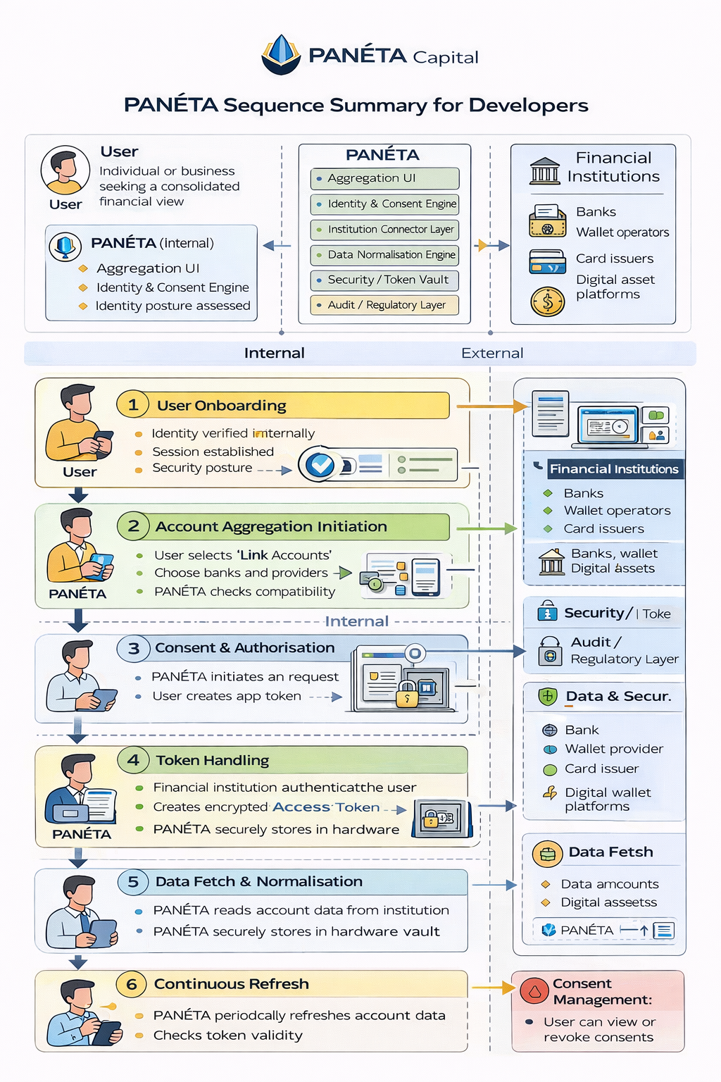

# PANÉTA Aggregation & Payments ERD — Explained

## 1What this ERD represents (big picture)

This ERD models **how PANÉTA aggregates financial data and orchestrates payment instructions** **without ever holding money, credentials, or balances**.

PANÉTA acts as:

* An **orchestrator**
* A **consent manager**
* A **routing and audit layer**

Financial Institutions remain:

* The **custodians of accounts**
* The **executors of transactions**
* The **owners of balances**

## 2Actors → Where they appear in the ERD

### User

Mapped to:

* **Users**

Users:

* Register
* Give consent
* View aggregated data
* Revoke consent

They **never touch execution or settlement**.

### PANÉTA (Internal Systems)

Mapped across **multiple entities**, not a single table:

| **PANÉTA Component** | **ERD Entities** |
| --- | --- |
| Aggregation UI | Users, Payment Requests |
| Identity & Consent Engine | User Consent |
| Institution Connector Layer | Destination Route, Payment Corridor |
| Data Normalisation Engine | Execution Log (post-processing view) |
| Security & Token Vault | Access Tokens |
| Audit & Regulatory Layer | Compliance Checks, Execution Log, Settlement Metadata |

PANÉTA is represented by **logic across tables**, not as a wallet or ledger.

### Financial Institutions (External)

Mapped to:

* **Institutions**
* **Destination Route**
* **Execution Log**
* **Settlement Metadata**

Institutions:

* Authenticate users
* Issue tokens
* Execute payments
* Confirm settlement

## 3Core ERD Entities (What each one means)

## Users

**Who is using PANÉTA**

* Stores identity info only
* No balances
* No wallets

Purpose:

Identify who is allowed to request aggregation or payments.

## User_Consent

**Legal permission layer**

* Links a user to an institution
* Defines jurisdiction & scope
* Required before any instruction

🔑 Purpose:

Enforces “no consent → no access”.

This directly supports:

* Stage 3 (Consent & Authorisation)
* Stage 10 (Consent Management)

## Payment Requests

**User intent (not execution)**

Examples:

* Send money
* Receive money
* QR / SoftPOS request

Contains:

* Amount
* Currency
* Request type

Purpose:

Capture what the user wants, not what happens.

## Payment Instruction

**Authorised, compliant command**

Created only after:

* Consent exists
* Routing is known
* Compliance checks pass

Status:

* Pending
* Executed
* Failed

Purpose:

This is the **handoff object** sent to institutions.

## Compliance Checks

**Regulatory enforcement**

Checks include:

* AML
* PEP
* Jurisdiction rules

Linked strictly to:

* Payment Instruction

Purpose:

Prevents illegal or non-compliant execution.

## Destination Route

**How execution will happen**

Defines:

* Institution
* Channel (Bank | Card | FX)
* Execution readiness

Purpose:

Separates decision-making from execution.

## Payment Corridor

**Geographic + regulatory path**

Encodes:

* Country pairing
* Regulatory rules
* Compliance boundaries

Purpose:

Makes cross-border and domestic flows explicit.

## Pricing_Fee

**PANÉTA’s platform fee**

* Calculated per instruction
* Linked to corridor
* Example: 0.99% per transaction

Purpose:

PANÉTA earns fees **without touching funds**.

## Execution Log

**What actually happened**

Written after institution execution:

* Amount settled
* Currency
* Timestamp

Purpose:

Immutable audit record, not settlement logic.

## Settlement Metadata

**Proof of settlement**

Provided by:

* Financial institution

Contains:

* Settled amount
* Settlement time

Purpose:

Confirms execution **outside PANÉTA**.

## Access Tokens

**Secure access keys**

* Issued by institutions
* Encrypted
* Time-limited
* Stored in vault

Purpose:

Enables read or execution access **without credentials**.

## 4.How this ERD maps to your 12 stages

|  |  |
| --- | --- |
| Stage | ERD Entities Involved |
| Stage 1 – Onboarding | Users |
| Stage 2 – Institution Selection | Institutions |
| Stage 3 – Authorisation | User Consent |
| Stage 4 – Consent Granting | User Consent, Access Tokens |
| Stage 5 – Token Storage | Access Tokens |
| Stage 6 – Data Fetch | Execution Log |
| Stage 7 – Normalisation | Execution Log |
| Stage 8 – Dashboard | Payment Requests, Execution Log |
| Stage 9 – Refresh | Access Tokens, Execution Log |
| Stage 10 – Revoke | User Consent |
| Stage 11 – Failure Handling | Execution Log |
| Stage 12 – Audit | Compliance Checks, Execution Log, Settlement Metadata |

## 5.Why this ERD is **Zero-Custody by design**

No wallet table  
No balance ledger  
No internal settlement engine  
No user funds account  
No credential storage

PANÉTA only:

* Routes
* Prices
* Audits
* Displays

## 6.Mental model (easy to remember)

**Payment Request** = intent  
**Payment Instruction** = authorised command  
**Destination Route** = who executes  
**Execution Log** = what happened

PANÉTA is the **control tower**, not the aircraft.

## 7.Final one-line summary

This ERD models PANÉTA as a zero-custody orchestration platform where users grant consent, PANÉTA issues compliant instructions, institutions execute transactions, and everything is auditable without PANÉTA ever holding money or credentials.

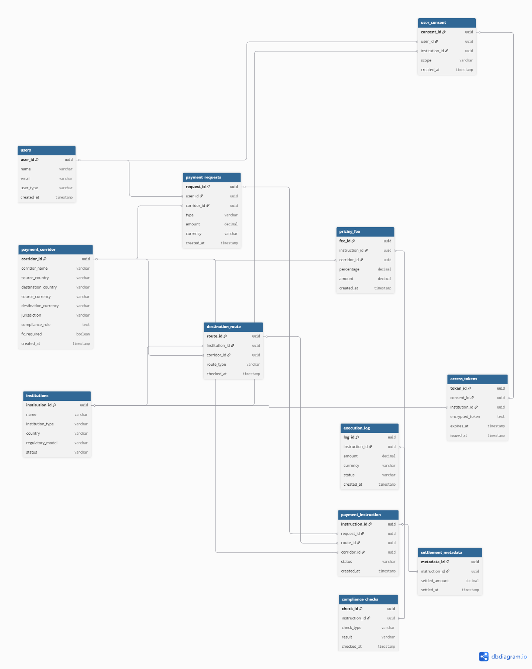

# PANÉTA — Send Money (Local / Same Currency)

## Sequence Diagram Explained (Developer-Friendly)

## 1.What this diagram shows (big picture)

The diagram shows **how a local, same-currency payment is executed without PANÉTA ever holding money**.

PANÉTA:

* Collects user intent
* Performs validation & compliance
* Generates a signed instruction
* Routes execution to licensed institutions
* Audits the outcome

Banks / wallets:

* Actually **move the funds**

## 2.Actors (swimlanes in the diagram)

### User

* Initiates and confirms the transaction

### PANÉTA (Internal)

* Orchestration layer
* Compliance & audit
* Instruction generation

### Issuer (Source)

* Holds sender’s funds
* Performs debit

### Acquirer (Destination)

* Receives funds
* Credits recipient

## 3.Stage-by-Stage Explanation

## **Stage 1 – User Initiation (Internal)**

**What you see in the diagram**

* User selects **Send Money**
* User selects **Issuer (source account)**

**What PANÉTA checks**

* User is authenticated
* Session is active
* Device risk checks already passed
* Issuer is linked
* Consent is valid
* Issuer supports local transfers
* Source and destination currencies match

**Developer meaning**  
This is **validation only**.  
No balances, no funds, no execution.

## **Stage 2 – Destination Definition (Internal)**

**What happens**

* User selects **Acquirer** (bank, wallet, card, digital wallet)
* User enters destination details (account, phone, token, wallet ID)

**PANÉTA validates**

* Input format
* Network / operator identification
* Local corridor eligibility
* Fraud / duplicate patterns

**Developer meaning**  
PANÉTA ensures the destination is real and supported **before** any transaction object exists.

## **Stage 3 – Transaction Intent Creation (Internal)**

**What happens**

* User enters amount and reference
* PANÉTA creates a **Transaction Intent**

**What a Transaction Intent is**

* Logical object (DB record / domain object)
* Contains:
  + Issuer ID
  + Acquirer ID
  + Amount
  + Currency
  + User ID
  + Timestamp

**Important**  
This is **not money** and **not execution**.

## **Stage 4 – Pre-Execution Controls (Internal)**

### 4.1 Issuer Capability Check

* PANÉTA asks the Issuer:

“Can this account execute this amount?”

PANÉTA:

* ❌ Does NOT fetch funds
* ❌ Does NOT lock funds
* ✅ Only checks readiness

### 4.2 Compliance & Risk

* KYC/KYB verified
* Sanctions screening
* Velocity limits
* Daily/monthly caps
* Local regulatory rules

### 4.3 Fees & Summary

* User sees:
  + Amount
  + PANÉTA fee
  + Total debit
* User confirms via PIN/biometric

**Developer meaning**  
All risk & compliance gates must pass **before instruction creation**.

## **Stage 5 – Payment Instruction Generation (Internal)**

**This is the most critical box in the diagram**

**What happens**

* PANÉTA creates a **Payment Instruction** containing:
  + Issuer ID
  + Acquirer ID
  + Amount & currency
  + Reference
  + Compliance metadata
  + Settlement routing

**Then**

* Instruction is digitally signed
* Instruction ID generated
* Immutable audit record written

**Still no money moved**

**Developer meaning**  
This is the **authorised command** that external systems will execute.

## **Stage 6 – Issuer Execution (External)**

**What happens**

* PANÉTA sends signed instruction to Issuer via:
  + Bank API
  + Wallet API
  + Card network
* Issuer validates:
  + PANÉTA authentication
  + Balance availability
  + Internal risk rules
* Issuer debits source funds **inside its own system**

**Developer meaning**  
Funds move **only inside the Issuer**, never PANÉTA.

## **Stage 7 – Settlement to Acquirer (External)**

**What happens**

* Issuer routes funds to Acquirer via:
  + Bank rails
  + Wallet rails
  + Card networks
* Acquirer:
  + Credits destination account
  + Updates ledger
  + Generates confirmation
* PANÉTA’s **0.99% fee** is credited separately

**Developer meaning**  
Settlement is **institution-to-institution**.

## **Stage 8 – Confirmation & Callbacks (External → Internal)**

**What happens**

* Acquirer confirms credit
* Issuer confirms debit
* Each sends:
  + Status
  + Timestamp
  + Reference number

🔑 **Developer meaning**  
PANÉTA receives **proof of execution**, not funds.

## **Stage 9 – PANÉTA Post-Execution Handling (Internal)**

**What happens**

* PANÉTA reconciles:
  + Debit confirmed
  + Credit confirmed
  + Amounts match
* Transaction marked **Completed**
* Audit trail sealed
* Notifications sent

**Developer meaning**  
This is reconciliation and state finalisation.

## **Stage 10 – Audit, Logging & Regulatory Visibility (Internal)**

**What happens**

* Immutable logs stored:
  + Instruction lifecycle
  + Issuer response
  + Acquirer response
  + Compliance decisions
* Regulators get:
  + Read-only access
  + Full traceability
  + No execution or custody power

**Developer meaning**  
Everything is auditable, nothing is mutable.

## 4.Mental model for developers (easy to remember)

User intent

↓

Transaction Intent

↓

Signed Payment Instruction

↓

Issuer debits

↓

Acquirer credits

↓

PANÉTA audits & notifies

## 5.One-line summary

PANÉTA never moves money — it validates intent, signs instructions, routes execution, and audits outcomes while licensed institutions handle all fund movement.

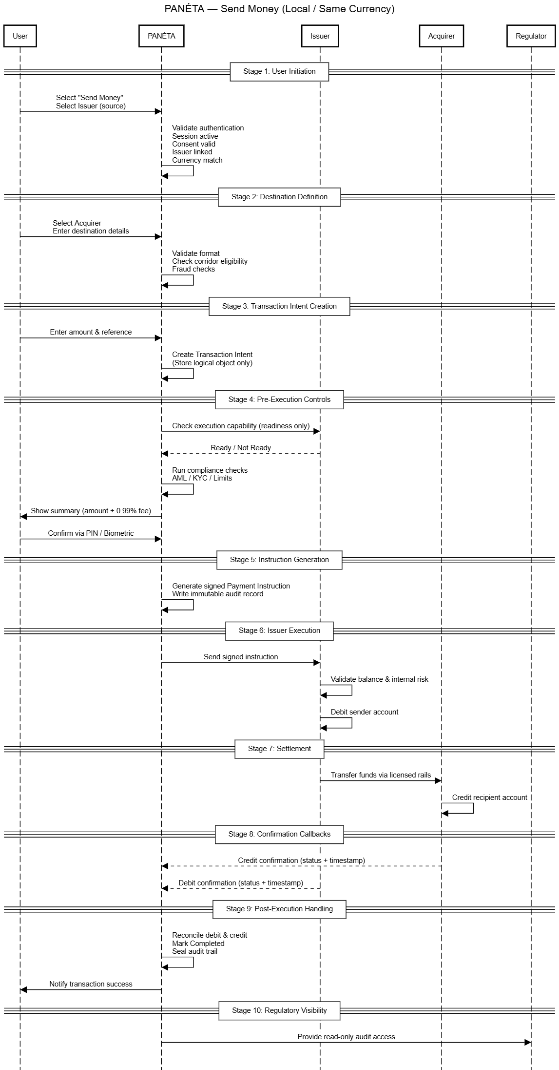

# PANÉTA — Payment Request / Receive Money

**Local • Same Currency**

### Sequence Diagram Explained (Developer-Friendly)

## 1What this flow is (big picture)

This flow covers **requesting money and getting paid**.

Key idea:

The **payee creates a request**, the **payer fulfils it**, PANÉTA **orchestrates and audits**, and **banks/wallets move the money**.

PANÉTA:

* never holds funds
* never credits balances
* creates requests & instructions
* enforces compliance
* records audit trails

## 2Actors (swimlanes in the diagram)

### Requesting User (Payee)

* Creates the payment request
* Chooses where money should be received

### PANÉTA (Internal)

* Builds request objects
* Validates risk & compliance
* Generates payment instructions
* Handles notifications & audit

### Paying User (Payer)

* Opens the request
* Selects how to pay
* Confirms payment

### Issuer (External – Source)

* Holds payer’s funds
* Performs debit

### Acquirer (External – Destination)

* Holds payee’s account
* Credits funds

## 3Stage-by-Stage Explanation

## **Stage 1 – Payment Request Creation (Internal)**

**What happens**

* Payee selects **Request Money**
* PANÉTA confirms:
  + User authenticated
  + Session & device risk OK
* Payee defines:
  + Amount (fixed or open)
  + Currency
  + Description
  + Expiry (optional)
  + Partial payment rules
* Payee selects **Acquirer** (bank, wallet, card, digital wallet)

**Important**  
No payer involved yet  
No money involved

## **Stage 2 – Payment Request Object Creation (Internal)**

**What PANÉTA creates**  
A **Payment Request object** (logical record):

* Request ID (globally unique)
* Payee identity
* Acquirer details
* Amount & currency
* Expiry rules
* Status = PENDING

**Also**

* Immutable audit log entry created

**Key point**  
This object represents **intent**, not money.

## **Stage 3 – Request Presentation (Internal)**

**What happens**  
PANÉTA generates a **shareable artefact**:

* QR code
* Payment link
* In-app request
* Invoice reference

The request is shared with the payer:

* PANÉTA user
* External user (QR / link)

## **Stage 4 – Payer Opens Payment Request (Internal)**

**What happens**

* Payer scans QR or opens link
* PANÉTA retrieves request details
* PANÉTA validates:
  + Request not expired
  + Not cancelled
  + Amount rules still valid

**Payer sees**

* Who is requesting
* Amount & currency
* Purpose
* Destination acquirer

Read-only view

## **Stage 5 – Payer Selects Issuer (Internal)**

**What happens**

* Payer selects **Issuer (source account)**:
  + Bank
  + Wallet
  + Card
  + Digital wallet

**PANÉTA validates**

* Issuer active
* Consent exists
* Issuer supports request fulfilment

Still no money touched

## **Stage 6 – Pre-Execution Controls (Internal)**

### 6.1 Funding Readiness

PANÉTA checks with Issuer:

* Can this amount be debited?
* Are limits, OK?

PANÉTA:

* ❌ does not fetch funds
* ❌ does not lock funds

### 6.2 Compliance & Risk

* KYC / KYB
* AML & sanctions
* Velocity & behaviour checks
* Purpose-of-payment validation

### 6.3 Fees & Confirmation

* Payer sees:
  + Amount
  + PANÉTA fee
  + Total debit
* Payer confirms via PIN / biometric

## **Stage 7 – Payment Instruction Generation (Internal)**

**What PANÉTA generates**  
A **Payment Instruction** referencing:

* Issuer (payer)
* Acquirer (payee)
* Amount & currency
* Request ID
* Compliance metadata

Then:

* Instruction is digitally signed
* Time-stamped
* Logged immutably

Still **no funds moved**

## **Stage 8 – Issuer Execution (External)**

**What happens**

* PANÉTA sends signed instruction to Issuer
* Issuer:
  + Authenticates PANÉTA
  + Performs final checks
  + Debits payer funds **inside its own system**

PANÉTA never sees or holds money

## **Stage 9 – Settlement to Acquirer (External)**

**What happens**

* Issuer routes funds to Acquirer via:
  + Domestic clearing
  + Wallet settlement
  + Card network
* Acquirer:
  + Credits payee account
* PANÉTA fee (e.g. 0.99%) credited separately

## **Stage 10 – Confirmations (External → Internal)**

**Confirmations received**

* Issuer confirms debit
* Acquirer confirms credit

PANÉTA receives **proof**, not funds

## **Stage 11 – Request Finalisation (Internal)**

**What happens**

* PANÉTA reconciles:
  + Debit ✔
  + Credit ✔
* Payment Request updated:
  + COMPLETED or PARTIALLY_FULFILLED
* Notifications sent:
  + Payee
  + Payer
* Receipt generated

## **Stage 12 – Audit & Regulatory Visibility (Internal)**

**Audit trail includes**

* Request lifecycle
* Instruction details
* Issuer & Acquirer confirmations
* Compliance decisions

**Regulators get**

* Read-only access
* Full traceability
* Zero custody exposure

## 4Mental model for developers

Payee creates request

↓

Request object stored

↓

Payer opens request

↓

Payer selects issuer

↓

Compliance & confirmation

↓

Signed payment instruction

↓

Issuer debits

↓

Acquirer credits

↓

PANÉTA audits & notifies

## 5One-line summary

PANÉTA enables “request & receive” payments by creating request objects and signed instructions, while licensed institutions debit and credit funds and PANÉTA only orchestrates, audits, and notifies.

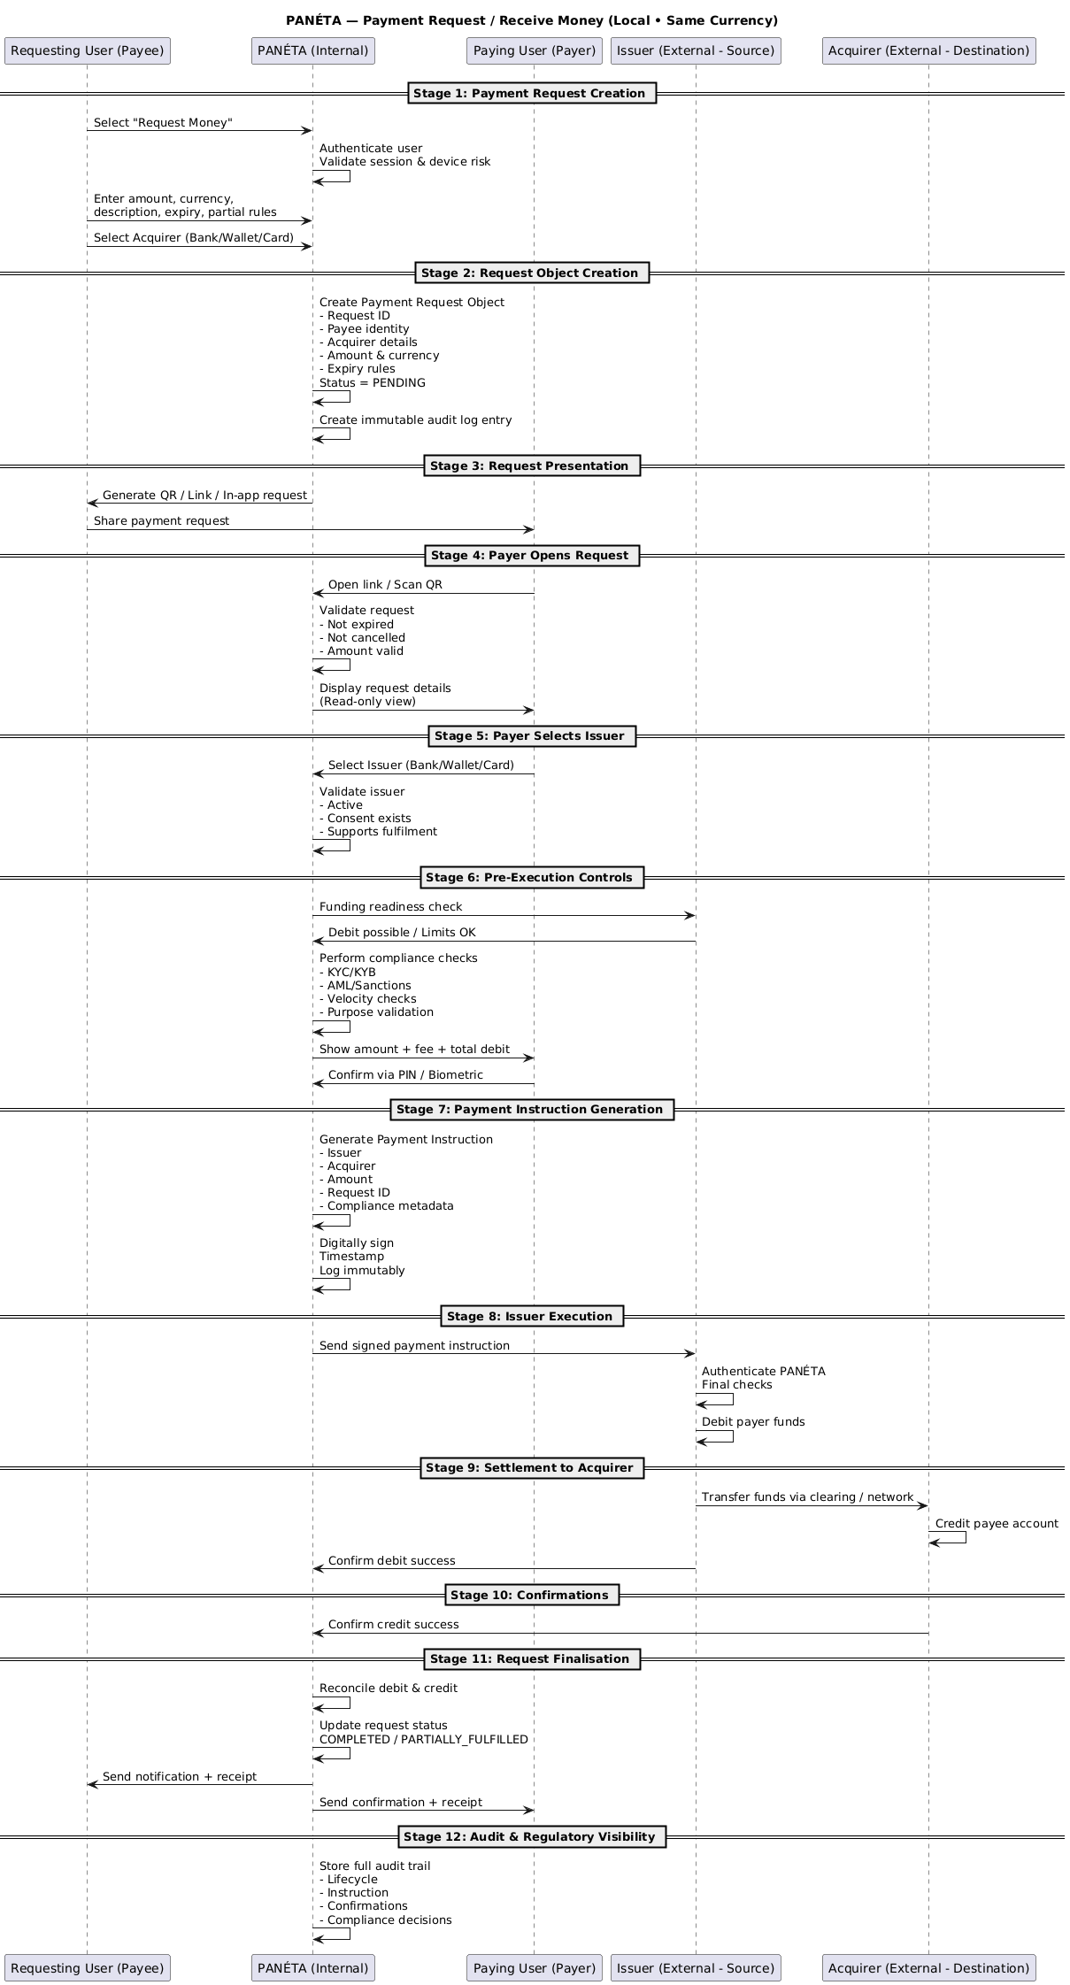

# PANÉTA Payments ERD — How “Send Money” Fits

## Big picture (one paragraph)

The ERD models **intent → instruction → execution → settlement → audit** in a **zero-custody** way.  
The **Send Money** sequence does **not** add new tables—it **moves through existing ones in a strict order**. PANÉTA creates intent and instructions; **Issuers/Acquirers execute funds**; PANÉTA logs and audits.

## ERD Sections (What each part is responsible for)

### Page 1 — Intent, Instruction & Compliance

* **Users**
* **User_Consent**
* **Payment_Request(s)**
* **Payment_Instruction**
* **Compliance_Checks**

This is where **Send Money is created, validated, and authorised**.

### Page 2 — Routing, Pricing & Execution

* **Destination_Route**
* **Payment_Corridor**
* **Pricing_Fee**
* **Execution_Log**
* **Settlement_Metadata**

This is where **Send Money is executed by institutions and audited**.

## Step-by-Step: Send Money → ERD Mapping

### ****Stage 1: User Initiation****

**ERD tables touched**

* Users
* User_Consent

**What happens**

* User session is already valid.
* PANÉTA checks:
  + Issuer linkage exists
  + Consent is valid (not revoked/expired)

**ERD meaning**

* No new records yet.
* Reads from Users and User_Consent.

### ****Stage 2: Destination Definition****

**ERD tables touched**

* Destination_Route
* Payment_Corridor

**What happens**

* PANÉTA validates destination details.
* Confirms:
  + Local corridor
  + Same currency
  + Supported network

**ERD meaning**

* Route & corridor are **selected**, not executed.
* Destination_Route + Payment_Corridor define **how** money would flow.

### ****Stage 3: Transaction Intent Creation****

**ERD table created**

* Payment_Request

**What happens**

* PANÉTA creates a **logical intent**:
  + Issuer
  + Acquirer
  + Amount
  + Currency
  + User

**ERD meaning**

* Payment_Request = **intent only**
* No funds, no execution.

### ****Stage 4: Pre-Execution Controls****

**ERD table created**

* Compliance_Checks

**What happens**

* PANÉTA runs:
  + KYC/KYB
  + Sanctions
  + Limits
  + Velocity checks

**ERD meaning**

* Each check is recorded in Compliance_Checks.
* If any fail → process stops here.

### ****Stage 5: Payment Instruction Generation****

**ERD table created**

* Payment_Instruction

**What happens**

* PANÉTA converts intent into an **authorised command**.
* Instruction includes:
  + Route
  + Amount
  + Compliance metadata
* Instruction is digitally signed.

**ERD meaning**

* Payment_Instruction is the **handoff object**.
* Still no money moved.

### ****Stage 6: Issuer Execution****

**ERD table written**

* Execution_Log (initial entry)

**What happens**

* PANÉTA sends instruction to Issuer.
* Issuer debits funds internally.

**ERD meaning**

* Execution_Log records:
  + Issuer response
  + Timestamp
  + Status
* PANÉTA never touches funds.

### ****Stage 7: Settlement to Acquirer****

**ERD tables written**

* Settlement_Metadata
* Pricing_Fee

**What happens**

* Issuer routes funds to Acquirer.
* Acquirer credits recipient.
* PANÉTA fee (e.g. 0.99%) is recorded.

**ERD meaning**

* Settlement_Metadata = proof of settlement.
* Pricing_Fee = PANÉTA revenue, not custody.

### ****Stage 8: Confirmations****

**ERD table updated**

* Execution_Log

**What happens**

* Issuer confirms debit.
* Acquirer confirms credit.

**ERD meaning**

* Execution_Log finalized with outcomes.

### ****Stage 9: Post-Execution Handling****

**ERD tables updated**

* Payment_Instruction (status → Completed)
* Execution_Log (reconciled)

**What happens**

* PANÉTA matches debit & credit.
* Marks transaction completed.
* Sends notifications.

### ****Stage 10: Audit & Regulatory Visibility****

**ERD tables used**

* Compliance_Checks
* Execution_Log
* Settlement_Metadata
* Pricing_Fee

**What happens**

* Immutable audit trail.
* Regulator gets read-only visibility.

## Visual Mental Model (ERD Flow)

Users

↓

User_Consent

↓

Payment_Request ← (Stage 3)

↓

Compliance_Checks ← (Stage 4)

↓

Payment_Instruction ← (Stage 5)

↓

Destination_Route + Payment_Corridor

↓

Execution_Log ← (Stages 6–8)

↓

Settlement_Metadata

↓

Pricing_Fee

## Why this ERD proves Zero-Custody

No wallet table  
No balances ledger  
No funds account  
Execution always external  
PANÉTA only creates **instructions & logs**

## One-line developer summary

**Send Money** flows through Payment_Request → Payment_Instruction → Execution_Log → Settlement_Metadata, with routing, pricing, and compliance layered in—PANÉTA orchestrates, institutions execute.

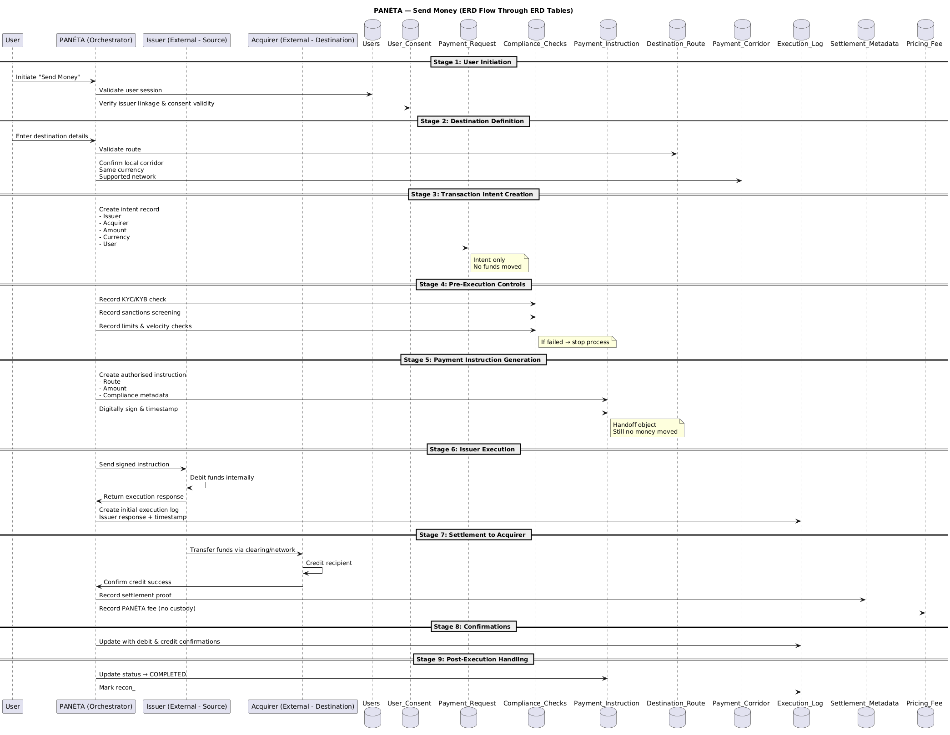

# PANÉTA — Send Money

## Cross-Border with FX Auto-Conversion

### Sequence Diagram Explained (Developer View)

## 1What this diagram represents (big picture)

This flow shows **how PANÉTA orchestrates an international transfer that requires FX conversion**, while **never holding money or FX positions**.

PANÉTA:

* Collects intent
* Discovers FX liquidity
* Locks an FX rate externally
* Generates a **composite instruction**
* Audits the entire lifecycle

Institutions:

* **Issuer** debits funds
* **FX Provider** converts currency
* **Acquirer** credits destination

## 2Actors (swimlanes in the diagram)

### User

* Initiates and confirms the transfer
* Approves FX rate and fees

### PANÉTA (Internal)

* UI & orchestration
* FX discovery and ranking
* Compliance & risk
* Instruction generation
* Audit & regulatory logging

### Issuer (External – Source)

* Holds sender’s funds
* Performs debit

### FX Provider(s) (External)

* Executes currency conversion
* Supplies executable FX rates

### Acquirer (External – Destination)

* Credits recipient in destination currency

## 3Stage-by-Stage Explanation

## **Stage 1 – User Initiation (Internal)**

**What happens**

* User selects **International Transfer**
* PANÉTA confirms:
  + User is authenticated
  + Session & device risk cleared
* User selects **Issuer (source account)**

**PANÉTA validates**

* Issuer is active
* Consent exists
* Cross-border transfers allowed
* Source currency identified

**Developer meaning**  
This is pre-flight validation only. No funds involved.

## **Stage 2 – Destination Definition (Internal)**

**What happens**

* User selects **Acquirer**
* User enters destination details (bank/wallet/card/digital wallet)
* User selects **destination country**

**PANÉTA determines**

* Destination country
* Destination currency
* FX required → **YES**

**Developer meaning**  
This stage decides whether FX logic is needed.

## **Stage 3 – Transaction Intent Creation (Internal)**

**What happens**

* User enters amount (source currency)
* PANÉTA creates a **Cross-Border Transaction Intent**

**Intent includes**

* Issuer & Acquirer details
* Source & destination currency
* Amount
* Corridor metadata
* FX required flag

**Important**  
This is a **logical object**, not money.

## **Stage 4 – Pre-Execution Controls (Internal)**

### 4.1 Issuer Capability Check

PANÉTA asks Issuer:

* Is balance sufficient?
* Is cross-border debit allowed?

PANÉTA:

* Does not lock funds
* Does not move funds

### 4.2 Compliance & Regulatory Screening

PANÉTA checks:

* Sanctions (sender, receiver, corridor)
* AML risk score
* Purpose of payment
* Jurisdiction rules
* FX controls (capital limits)

**Developer meaning**  
All regulatory gates must pass before FX discovery.

## **Stage 5 – FX Auto-Conversion Discovery (Internal)**

**What happens**

* PANÉTA sends RFQs to:
  + Banks
  + Licensed FX dealers
  + Liquidity providers

**FX Providers respond with**

* Executable FX rates
* Fees
* Rate expiry
* Settlement method

**PANÉTA normalises & ranks**

* Best net rate
* Reliability
* Speed
* Regulatory suitability

**Developer meaning**  
PANÉTA acts as an **FX router**, not a dealer.

## **Stage 6 – User FX Confirmation (Internal)**

**What user sees**

* Source amount
* FX rate
* Destination amount
* Fees
* FX provider (if required)
* Rate expiry countdown

**User confirms**

* PIN / biometric

**Important**  
FX rate is locked **at the FX provider**, not PANÉTA.

## **Stage 7 – Payment & FX Instruction Generation (Internal)**

**What happens**  
PANÉTA creates a **Composite Instruction** with two atomic legs:

### Leg A – Debit & FX

* Issuer debits source currency
* FX Provider converts currency

### Leg B – Credit Destination

* Converted funds sent to Acquirer
* Acquirer credits destination

**Instruction is**

* Digitally signed
* Time-stamped
* Logged immutably

**Developer meaning**  
This is an **all-or-nothing orchestration command**.

## **Stage 8 – Issuer Execution (External)**

**What happens**

* PANÉTA sends instruction to Issuer
* Issuer:
  + Authenticates PANÉTA
  + Performs final checks
  + Debits source funds

Funds move **only inside Issuer systems**.

## **Stage 9 – FX Execution (External)**

**What happens**

* Issuer routes funds to FX Provider
* FX Provider:
  + Sells source currency
  + Buys destination currency
  + Settles internally
* FX Provider confirms execution

**Developer meaning**  
FX risk is fully externalised.

## **Stage 10 – Settlement to Acquirer (External)**

**What happens**

* Converted funds sent to Acquirer
* Acquirer:
  + Credits destination account
* PANÉTA fee (e.g. 0.99%) credited separately

**Developer meaning**  
Settlement is institution-to-institution.

## **Stage 11 – Confirmations & Callbacks**

**Confirmations received from**

* FX Provider → FX executed
* Issuer → debit completed
* Acquirer → credit completed

## **Stage 12 – PANÉTA Post-Execution Handling (Internal)**

**What happens**

* PANÉTA reconciles:
  + Debit ✔
  + FX ✔
  + Credit ✔
* Transaction marked **COMPLETED**
* User notified
* Exception handling if partial failures occur

## **Stage 13 – Audit & Regulatory Visibility (Internal)**

**Audit trail includes**

* FX rate used
* FX provider
* Jurisdictions crossed
* Compliance decisions

**Regulators get**

* Read-only visibility
* Full traceability
* No execution or custody risk

## 4Mental model for developers

User intent

↓

Cross-Border Transaction Intent

↓

FX Discovery & Rate Lock

↓

Composite Instruction (Debit + FX + Credit)

↓

Issuer debits → FX converts → Acquirer credits

↓

PANÉTA reconciles & audits

## 5One-line summary

PANÉTA orchestrates cross-border FX payments by discovering liquidity, locking rates externally, issuing composite instructions, and auditing outcomes—without ever holding funds or FX positions.

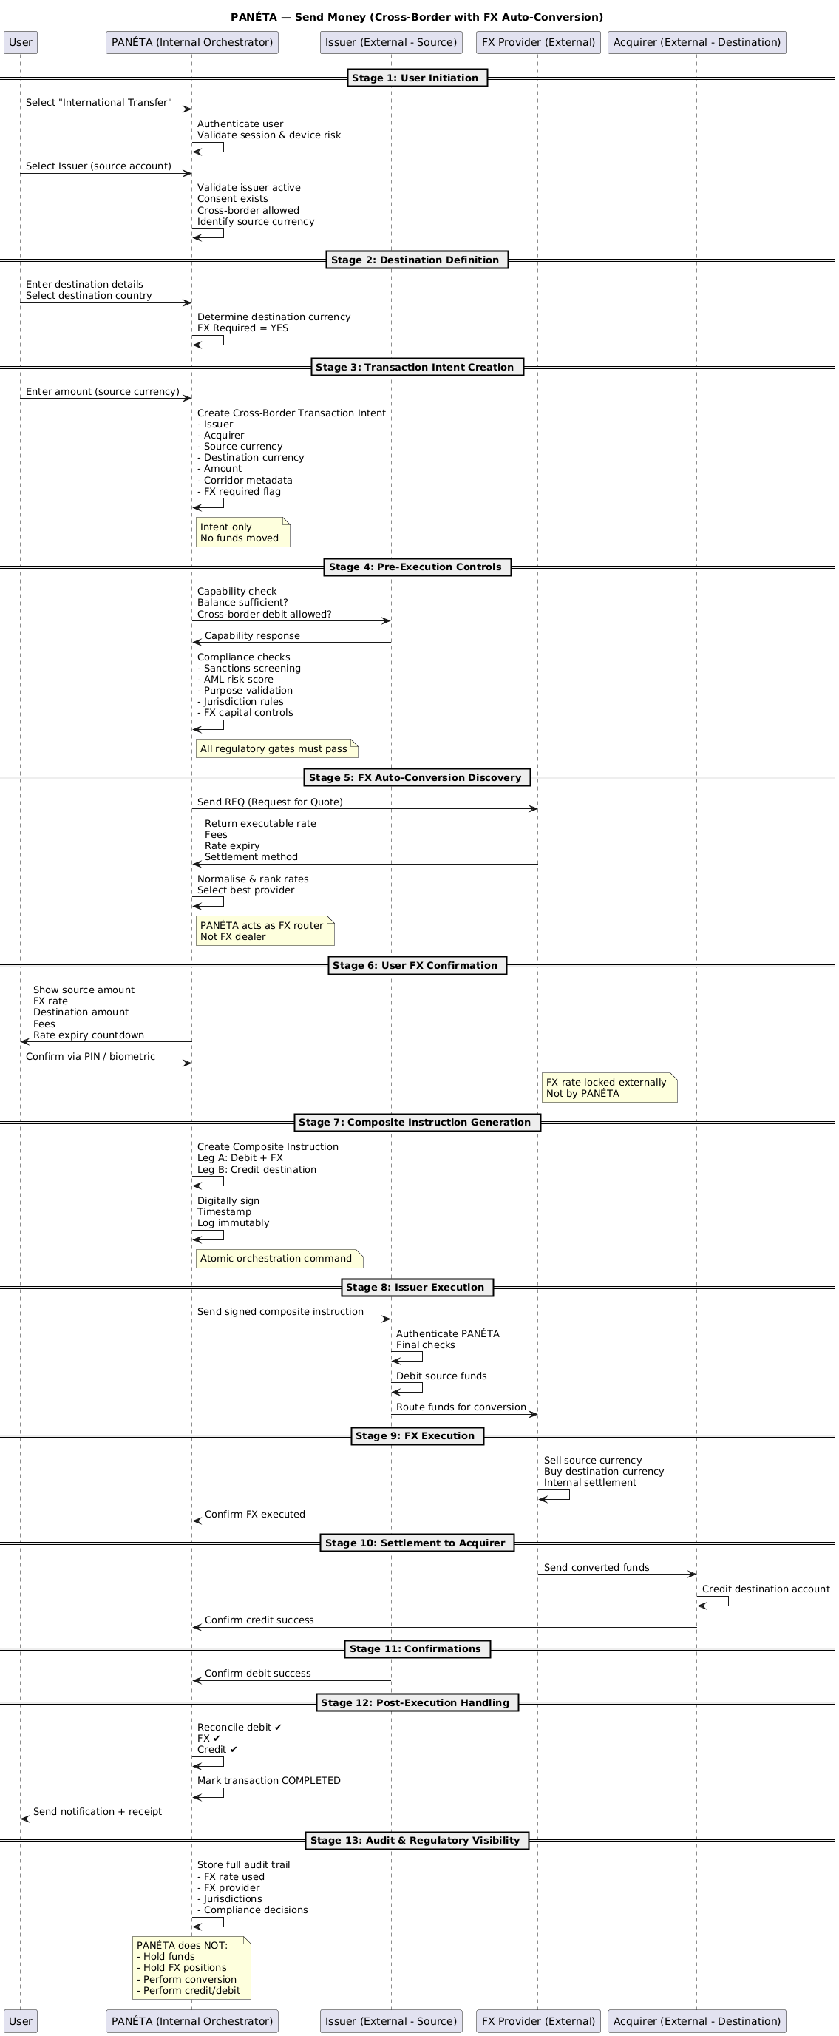

# PANÉTA — Merchant Payments (SoftPOS)

## End-to-End Orchestration Model (Explained)

## 1 What this diagram represents (big picture)

This diagram shows **how a merchant accepts a payment using PANÉTA SoftPOS**, while **PANÉTA never becomes a payment processor or fund holder**.

**Core idea:**

PANÉTA creates and orchestrates payment instructions.  
Banks, wallets, card networks, and FX providers actually move the money.

SoftPOS is **only a merchant-side initiation interface**.

## 2Foundational principles (why the design looks this way)

These rules shape the entire diagram:

* PANÉTA does **not** acquire funds
* PANÉTA does **not** settle merchant balances
* PANÉTA does **not** hold merchant float
* PANÉTA **only orchestrates payment instructions**

This is why:

* There is **no wallet or balance inside PANÉTA**
* All debits and credits happen **externally**

## 3 Actors (the vertical lanes in the diagram)

### Merchant (Payee)

* Uses PANÉTA SoftPOS (phone/tablet)
* Enters amount and initiates payment

### PANÉTA (Internal)

* SoftPOS UI
* Merchant orchestration
* Compliance & risk
* Instruction generation
* Audit & reconciliation

### Customer (Payer)

* Pays using their preferred bank, wallet, or card

### Issuer (External – Source)

* Holds customer funds
* Performs the debit

### Acquirer (External – Destination)

* Holds merchant settlement account
* Credits merchant funds

## 4PART A — Local / Same-Currency SoftPOS Flow

## **Stage 1: Merchant Payment Initiation (Internal)**

**What happens**

* Merchant opens PANÉTA SoftPOS
* PANÉTA confirms:
  + Merchant authenticated
  + Device registered
  + KYB already approved
* Merchant enters:
  + Amount
  + Currency (local)
  + Description / invoice reference
* Merchant selects **Acquirer** (bank / wallet / digital wallet)

**Important**  
No customer involved yet  
No money involved

## **Stage 2: Payment Request Object Creation (Internal)**

**What PANÉTA creates**  
A **Merchant Payment Request object**:

* Merchant ID
* Acquirer details
* Amount & currency
* Expiry
* Status = AWAITING_PAYMENT

This object is:

* Digitally signed
* Time-stamped
* Logged immutably

This is **not money**, just intent.

## **Stage 3: Customer Presentation (Internal)**

**What happens**

* PANÉTA generates a payment artefact:
  + Dynamic QR code
  + NFC tap-to-pay
  + Payment link (optional)
* Customer sees:
  + Merchant name
  + Amount
  + Currency
  + Reference

PANÉTA is acting as a **request presenter**, not a processor.

## **Stage 4: Customer Selects Issuer (Internal)**

**What happens**

* Customer selects how to pay:
  + Bank account
  + Wallet
  + Card
  + Digital wallet
* PANÉTA validates:
  + Issuer is active
  + Consent exists
  + Same-currency supported

PANÉTA checks **eligibility**, not balances.

## **Stage 5: Pre-Execution Controls (Internal)**

### 5.1 Funding Readiness

* PANÉTA asks Issuer:
  + “Can this amount be debited?”

PANÉTA:

* ❌ does not fetch funds
* ❌ does not lock funds

### 5.2 Compliance & Risk

* AML & sanctions
* Velocity & fraud rules
* Merchant & customer risk

### 5.3 Fees & Confirmation

* Customer sees:
  + Amount
  + PANÉTA fee
  + Total debit
* Customer confirms with PIN / biometric

## **Stage 6: Payment Instruction (Internal)**

**What PANÉTA generates**  
A **Merchant Payment Instruction** containing:

* Issuer (customer source)
* Acquirer (merchant destination)
* Amount & currency
* Merchant reference
* Compliance metadata

Instruction is:

* Digitally signed
* Logged immutably

Still **no funds moved**.

## **Stage 7: Issuer Execution (External)**

**What happens**

* PANÉTA sends instruction to Issuer
* Issuer:
  + Authenticates PANÉTA
  + Runs final checks
  + Debits customer funds **inside its own system**

Funds never touch PANÉTA.

## **Stage 8: Settlement to Acquirer (External)**

**What happens**

* Issuer routes funds via:
  + Domestic clearing rail
  + Wallet settlement
  + Card acquiring network
* Acquirer:
  + Credits merchant settlement account
* PANÉTA fee (e.g. 0.99%) credited separately

## **Stage 9: Confirmation & Completion (Internal)**

**What happens**

* Issuer confirms debit
* Acquirer confirms credit
* PANÉTA:
  + Reconciles confirmations
  + Marks transaction COMPLETED
  + Notifies merchant instantly
  + Generates customer receipt

## 5PART B — Cross-Border / FX SoftPOS (What changes)

Everything stays the same **except**:

* PANÉTA detects currency mismatch
* FX discovery is triggered
* FX providers return executable rates
* Customer confirms FX rate
* A **composite instruction** is generated:
  + Debit → FX conversion → Merchant credit
* FX happens **outside PANÉTA**

PANÉTA still:

* Holds no funds
* Holds no FX position

## 6Mental model for developers

Merchant enters amount

↓

Payment Request object

↓

Customer scans / taps

↓

Issuer selected

↓

Compliance & confirmation

↓

Signed payment instruction

↓

Issuer debits customer

↓

Acquirer credits merchant

↓

PANÉTA reconciles & notifies

## 7One-line summary

PANÉTA SoftPOS lets merchants initiate payments, while licensed issuers, FX providers, and acquirers execute all fund movement and PANÉTA only orchestrates, audits, and notifies.

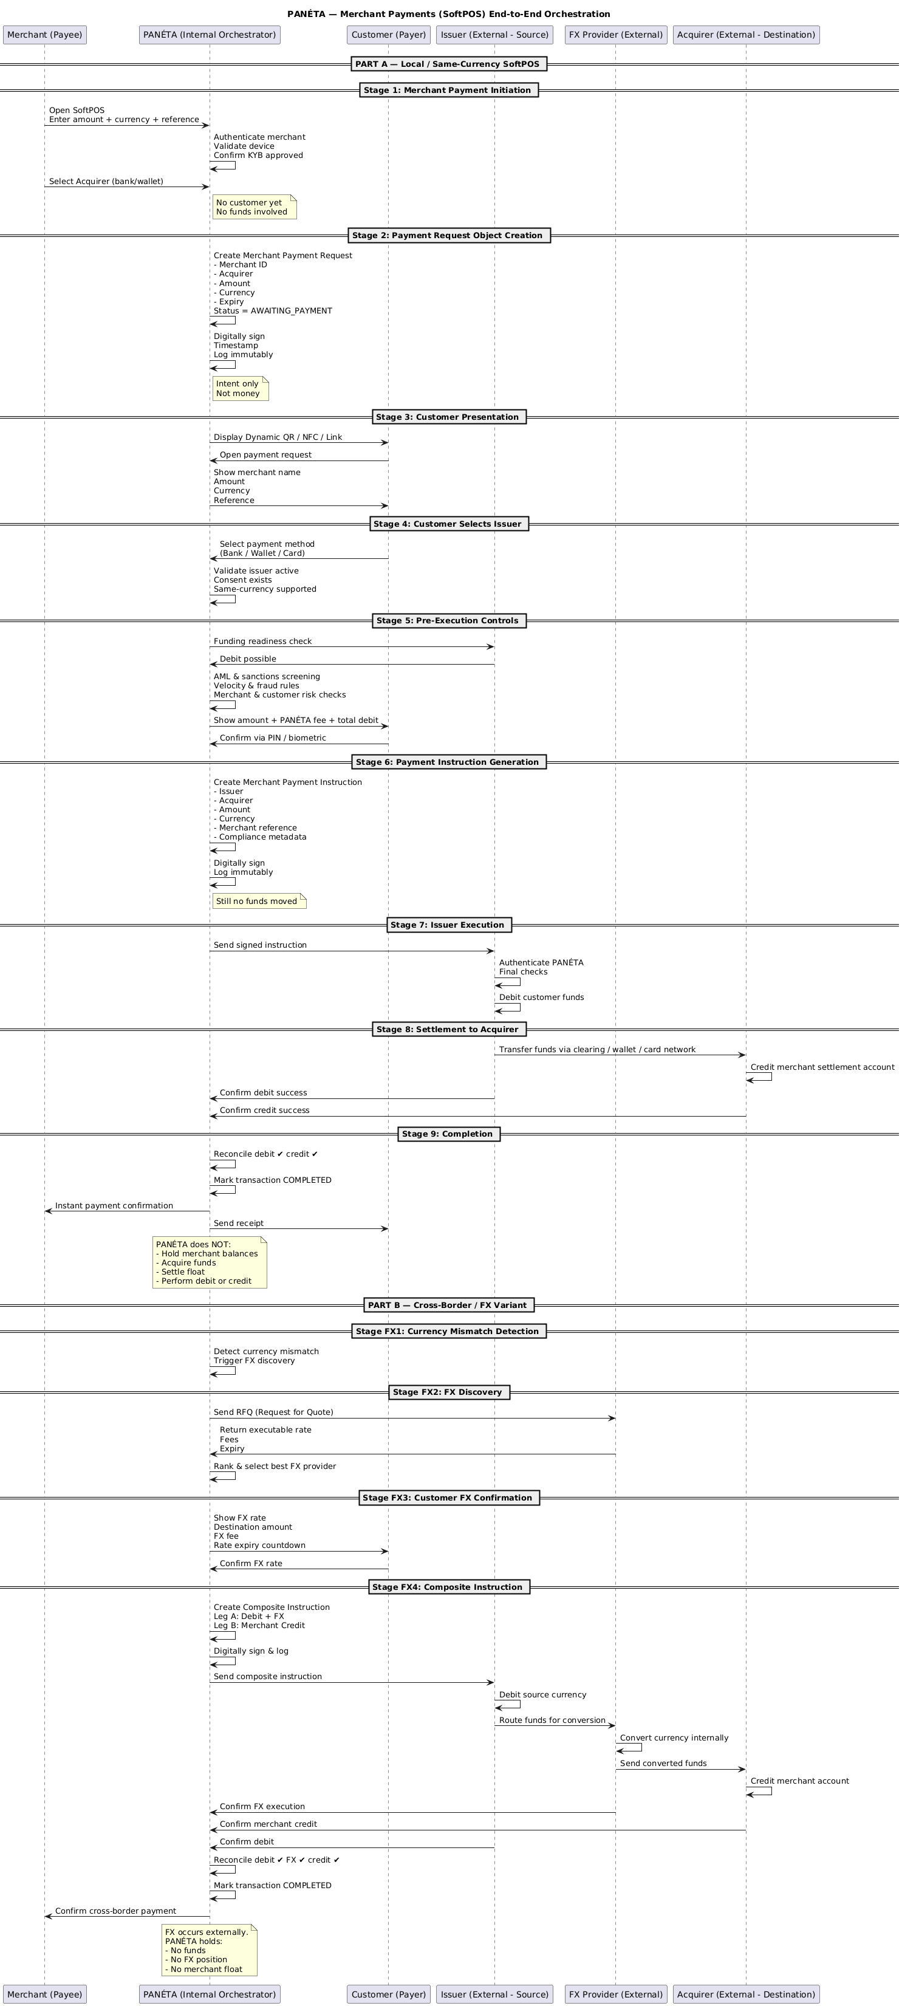

# PANÉTA — P2P FX Exchange

## Smart Escrow Orchestration (Explained Simply)

## 1What this diagram represents (in plain terms)

This diagram shows how **two users exchange currencies directly with each other**, while:

* **PANÉTA never holds money**
* **Funds stay inside banks / wallets**
* **Both FX legs must succeed together**

Think of PANÉTA as a **trusted referee** that:

* Matches users
* Confirms readiness
* Coordinates atomic execution
* Records everything for audit

## 2Core principle (why “Smart Escrow”)

### Traditional Escrow

* Platform holds money
* Custody risk
* Regulatory burden

### PANÉTA Smart Escrow

* No wallet
* No holding
* No locking funds

Instead:

* PANÉTA tracks a **logical escrow state**
* Instructions are **conditional**
* Execution is **all-or-nothing**

Money only moves **after both sides are ready**.

## 3️Actors in the diagram

### FX Initiator (User A)

* Wants to exchange Currency **X → Y**

### FX Counterparty (User B)

* Wants to exchange Currency **Y → X**

### PANÉTA (Internal)

* FX marketplace
* Smart escrow engine
* Compliance & risk checks
* Instruction orchestration
* Audit & regulatory layer

### Issuers (External)

* Hold User A & B funds
* Perform debits

### Acquirers (External)

* Credit converted currencies
* Settle the trade

## 4Stage-by-Stage Explanation

## **Stage 1 — FX Offer Creation**

**What happens**

* User A creates an FX offer:
  + Currency pair
  + Amount
  + Desired rate
  + Expiry
* PANÉTA validates:
  + KYC/KYB
  + Jurisdiction rules
  + FX limits

**Result**

* FX Offer Object created
* Status = OPEN

No funds touched  
No balances locked

## **Stage 2 — Offer Discovery & Matching**

**What happens**

* Offer is listed in PANÉTA’s FX marketplace
* Only eligible users see it
* User B reviews and accepts

**State change**

* Offer → PENDING_ESCROW_VALIDATION

## **Stage 3 — Smart Escrow Preconditions**

This is the **safety gate**.

### Issuer readiness checks (both users)

PANÉTA asks:

* Is balance sufficient?
* Is FX allowed?
* Any blocks?
* Cross-border permitted?

Still:

* No debit
* No hold
* No custody

### Compliance checks

* AML / sanctions
* Behavioural risk
* Jurisdiction FX rules

If either side fails → flow stops safely

## **Stage 4 — Logical Escrow Activation**

This is **not money escrow**.

**What escrow means here**

* Both sides confirmed ready
* FX terms locked
* Execution must be atomic

Users see:

* Amount
* Fees
* Total debit

Both users confirm (PIN / biometric)

Execution window opens (5–10 min)

## **Stage 5 — Atomic FX Instruction Creation**

PANÉTA creates **one linked instruction with two legs**:

### Leg A

* Issuer A debits Currency X
* Acquirer credits User B in Currency Y

### Leg B

* Issuer B debits Currency Y
* Acquirer credits User A in Currency X

**Key rule**

* Legs are **linked**
* Either both execute or none execute

## **Stage 6 — Execution Phase (External)**

PANÉTA sends both legs **simultaneously**.

Issuers:

* Authenticate PANÉTA
* Perform final checks
* Execute debits together

If one fails → execution halts

## **Stage 7 — Settlement & Credit**

* Acquirers credit destination accounts:
  + User A receives Currency Y
  + User B receives Currency X
* Settlement occurs **outside PANÉTA**
* PANÉTA fee credited separately

## **Stage 8 — Confirmation & Escrow Release**

PANÉTA receives:

* Debit confirmations
* Credit confirmations

PANÉTA:

* Closes escrow state
* Marks FX trade COMPLETED

## **Stage 9 — Failure & Safety Handling**

### Partial failure prevention

* One leg fails → no loss on the other side

### Timeout handling

* FX rate expires
* Escrow cancelled
* No funds moved

### Disputes

* Full audit trail
* No custody exposure

## **Stage 10 — Audit & Regulatory Visibility**

PANÉTA stores:

* Offer creation
* Acceptance
* Escrow activation
* Execution logs
* Jurisdictions crossed

Regulators get:

* Read-only access
* FX transparency
* Zero shadow conversion risk

## 5Developer mental model (easy to remember)

Offer created

↓

Offer matched

↓

Issuers confirm readiness

↓

Logical escrow activated

↓

Both users confirm

↓

Dual-leg instruction created

↓

Issuers execute simultaneously

↓

Acquirers credit

↓

Escrow closed

## 6One-line summary

PANÉTA enables safe peer-to-peer FX by coordinating atomic, conditional instructions while all funds remain with licensed institutions and no escrow money is ever held.

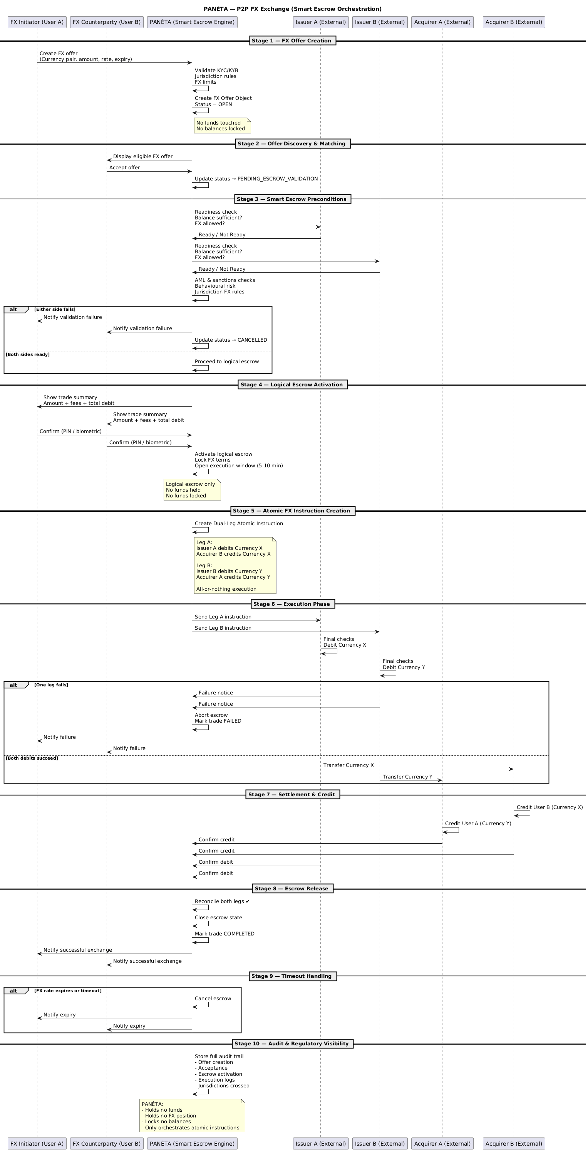

# PANÉTA — Wealth Management Technology

## Zero-Custody • Read-Only • Decision-Support (Explained)

PANÉTA’s Wealth platform **aggregates and analyses investment data** from banks, brokers, fund platforms, and digital asset custodians to give users **visibility, analytics, risk insights, and “what-if” scenarios**.

**PANÉTA never:**

* Holds assets
* Executes trades
* Gives investment advice
* Rebalances portfolios
* Controls user money

It is **analytics and intelligence only**.  
All assets stay with **external custodians**.

## 2Core principles (why the diagram looks like this)

These rules shape every box and arrow in the diagram:

1. **No custody** – assets never move into PANÉTA
2. **No execution** – PANÉTA cannot place trades
3. **No advice** – insights are informational, not prescriptive
4. **No discretion** – users always decide externally
5. **No commingling** – data and funds are isolated per institution

This makes the platform **low-risk, regulator-friendly, and scalable**.

## 3Actors (swimlanes in the diagram)

### User (All Tiers)

* Retail investor
* Financial professional
* Asset manager
* Institutional client

### PANÉTA (Internal Engines)

* Subscription & entitlement
* Asset aggregation
* Valuation & analytics
* Risk & exposure
* Scenario modelling
* Compliance & audit

### External Asset Platforms

* Banks
* Brokers
* Fund administrators
* Digital asset custodians

These **hold and administer the assets**

## 4End-to-End Flow Explained

## **Stage 1 — User Onboarding & Eligibility**

* User enables Wealth features
* Risk tier assessed
* Wealth disclosures accepted:
  + No advice
  + No execution
  + Read-only
* Subscription tier assigned (Silver → Diamond)
* Audit record created

Access level is controlled **before any data is pulled**

## **Stage 2 — Asset Aggregation Initiation**

* User selects investment accounts to link
* PANÉTA checks:
  + Jurisdiction compatibility
  + Read-only access support
  + Aggregation method availability
* Tier rules enforced (limits depend on subscription)

PANÉTA only prepares the connection

## **Stage 3 — Consent & Authorisation**

* User redirected to institution’s consent flow
* Institution authenticates user
* User grants **read-only, time-bound, revocable consent**
* PANÉTA never sees credentials

Security and legal responsibility stay with the institution

## **Stage 4 — Token Handling & Security(we can have a call over this )**

* PANÉTA receives encrypted access tokens
* Tokens stored in a hardware-backed vault
* Continuous monitoring for expiry or revocation

Tokens allow **data access only**, nothing else

## **Stage 5 — Initial Asset Data Ingestion**

* PANÉTA requests:
  + Holdings
  + Quantities
  + Prices / NAVs
  + Cost basis (if available)
  + Currency
* Institutions respond with source-owned data

Data flows **institution → PANÉTA**, never the reverse

## **Stage 6 — Data Normalisation & Classification**

PANÉTA standardises everything:

* Asset classes (equities, bonds, funds, crypto, cash)
* Currencies
* Valuation dates
* Corporate actions

Assets are tagged by:

* Geography
* Sector
* Instrument type
* Risk category

This makes data comparable and usable

## **Stage 7 — Dashboard Generation (Tier-Aware)**

### Silver (Retail, Free)

* Basic aggregation
* Delayed prices
* Simple calculations
* Ads shown
* Hard feature limits

### Gold (Professionals)

* Real-time data
* Advanced analytics
* Risk metrics
* Watchlists & screeners
* No ads

### Platinum (Asset Managers)

* Multi-client portfolios
* Cross-portfolio exposure
* Compliance alerts
* Branded reports

### Diamond (Institutions)

* Full API access
* Automated reporting
* Team roles
* Advanced scenario analytics
* Secure auditor data room

**Same data pipeline**, different feature unlocks

## **Stage 8 — Valuation & Performance Analytics**

* Real-time or delayed valuations
* FX-adjusted values
* Historical snapshots
* Returns & contribution analysis

PANÉTA calculates, **never executes**

## **Stage 9 — Risk & Exposure Analysis**

* Concentration risk
* Currency exposure
* Geographic exposure
* Volatility indicators

All outputs are **informational**, not recommendations.

## **Stage 10 — Scenario & What-If Modelling**

User runs simulations like:

* Market downturn
* Currency depreciation
* Hypothetical rebalancing

PANÉTA:

* Simulates outcomes
* Shows impacts
* Executes nothing

## **Stage 11 — Insights & Decision Support**

PANÉTA generates neutral insights:

* “Currency exposure exceeds X%”
* “Single-asset concentration detected”
* “Volatility increased”

No advice wording.  
Everything is logged and auditable.

## **Stage 12 — User Action Pathways**

If user wants to act:

* PANÉTA redirects externally:
  + Bank
  + Broker
  + Adviser

PANÉTA **never places orders**.

## **Stage 13 — Continuous Data Refresh**

* Scheduled refresh
* User-initiated refresh
* Institution updates
* Token validity checked each time

## **Stage 14 — Consent & Access Management**

* User sees all linked institutions
* Can revoke consent at any time
* Tokens invalidated instantly
* Audit entry created

## **Stage 15 — Subscription & Entitlement Enforcement**

* Billing engine handles upgrades/downgrades
* Feature access adjusted
* Data depth and API access gated
* No disruption to existing visibility

## **Stage 16 — Audit & Regulatory Visibility**

* Immutable audit trail covers:
  + Consent lifecycle
  + Data access
  + Analytics generation
  + Insight delivery
* Regulators get:
  + Read-only access
  + Full traceability
  + Zero custody & advice risk

## 5Developer mental model (simple)

Link accounts

↓

Read-only data pulled

↓

Normalize & classify

↓

Analyze & simulate

↓

Show insights

↓

User acts elsewhere

## 6 One-line summary

PANÉTA’s Wealth Technology aggregates and analyses investment data to provide visibility and decision support, while all assets remain with external custodians and no trades, advice, or custody ever occur.

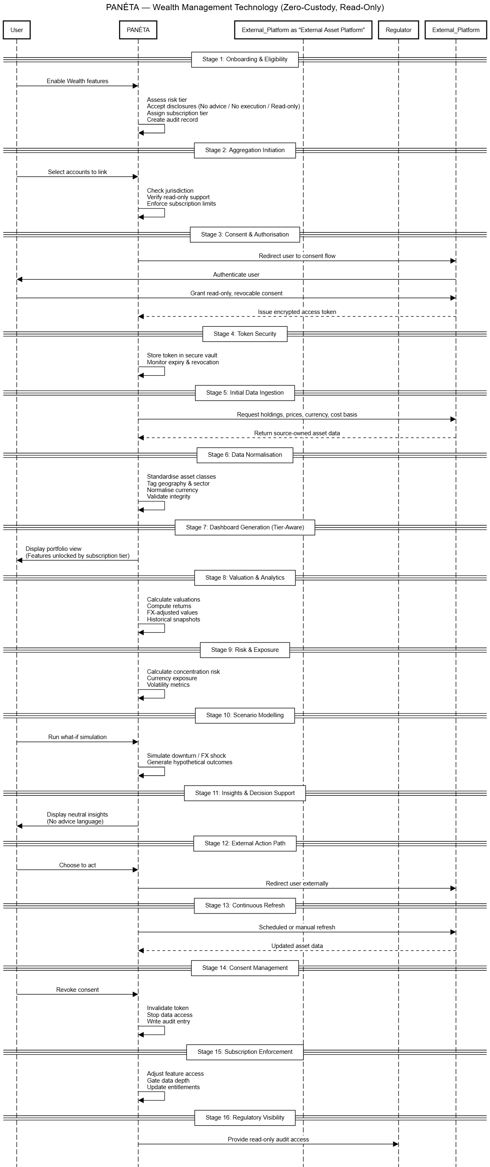

# PANÉTA — Peer-to-Global FX Marketplace

**Neutral Liquidity Orchestration Model**

# 1WHO ARE THE LANES (Swimlanes at the Top)

From left to right:

### FX Initiator (Peer / Client)

The user who wants to exchange currency.

### PANÉTA (Global FX Marketplace Engine)

The orchestration layer:

* RFQ engine
* Liquidity normalisation
* Compliance
* Instruction generator
* Audit layer

### Issuer (External – Source of Funds)

The user’s bank / wallet holding source currency.

### Global FX Liquidity Providers (External)

* Tier-1 banks
* FX dealers
* Market makers  
  They provide executable FX quotes.

### Acquirer (External – Destination)

The bank / wallet receiving the converted currency.

# 2CORE PRINCIPLE (The Yellow Box at the Top)

This is the most important part of the diagram.

PANÉTA:

* ❌ Is NOT an FX dealer
* ❌ Takes NO FX positions
* ❌ Holds NO client funds
* ❌ Does NOT intermediate settlement
* ✅ Only orchestrates global FX liquidity access

This defines the entire architecture.

PANÉTA is infrastructure — not a trading counterparty.

# 3STAGE-BY-STAGE FLOW

## Stage 1 — FX Intent Initiation

User selects:

“Exchange Currency”

User defines:

* Source currency
* Destination currency
* Amount
* Settlement preference
* Execution preference

PANÉTA validates:

* KYC tier
* FX limits
* Jurisdiction rules
* Currency pair availability

Key note in diagram:

“No funds moved – Intent only”

This is just validation.

## Stage 2 — FX Market Order Object Creation

PANÉTA creates a structured object containing:

* Order ID
* Currency pair
* Amount
* Jurisdictions
* Compliance metadata
* Execution rules
* Status = Pending Liquidity

Then:

* Digitally signed
* Timestamped
* Immutable audit record

This is a logical representation of the FX demand.

Still no money moved.

## Stage 3 — Global Liquidity Discovery

PANÉTA broadcasts RFQs simultaneously to:

* Global banks
* FX dealers
* Market makers
* Regional providers

The RFQ includes:

* Currency pair
* Amount
* Settlement window
* Compliance context

🧠 Important note in diagram:

“PII not exposed to liquidity providers”

This protects:

* User privacy
* Market fairness
* Prevents front-running

## Stage 4 — Liquidity Response & Normalisation

Liquidity providers respond with:

* Executable FX rate
* Available depth
* Fees
* Expiry
* Settlement method

PANÉTA:

* Normalises quotes
* Standardises format
* Calculates net outcomes

Now all quotes are comparable.

## 🔹 Stage 5 — Price Discovery & Best Execution

PANÉTA ranks providers based on:

* Best net FX rate
* Reliability
* Speed
* Jurisdiction compatibility
* Provider risk score

The diagram shows an alt block:

### If large order:

Split across multiple liquidity providers.

### If standard order:

Select single best provider.

Important note in diagram:

No internalisation of flow  
No position taken

PANÉTA does not:

* Trade against user
* Warehouse risk
* Take spread from inventory

## 🔹 Stage 6 — User Quote Review & Confirmation

User sees:

* Source debit amount
* FX rate(s)
* Destination amount
* Liquidity provider(s)
* Fees
* Expiry countdown

User confirms.

Diagram note:

FX rate locked at liquidity provider level — not locked by PANÉTA.

PANÉTA never takes rate risk.

## 🔹 Stage 7 — Pre-Execution Controls

PANÉTA checks with Issuer:

* Balance sufficient?
* FX-enabled account?

Issuer responds readiness confirmation.

PANÉTA runs final compliance:

* AML / sanctions
* Capital controls
* Market abuse rules

Still no debit yet.

## Stage 8 — Composite FX Instruction Generation

PANÉTA generates one signed instruction containing:

### Leg A — Debit & FX

* Issuer debits source currency
* Liquidity provider executes FX

### Leg B — Credit

* Converted funds routed
* Acquirer credits destination

Instruction is:

* Digitally signed
* Timestamped
* Logged immutably

This is orchestration — not execution.

## Stage 9 — Issuer Debit (External)

Issuer:

* Authenticates PANÉTA
* Debits source funds
* Routes funds per instruction

Funds never touch PANÉTA.

## Stage 10 — Global FX Execution (External)

Liquidity provider:

* Executes FX trade
* Settles via its own infrastructure
* Confirms execution

Diagram note:

PANÉTA does not sit in settlement layer  
No intermediary account

This removes:

* Custody risk
* Clearing risk
* Settlement exposure

## Stage 11 — Settlement to Acquirer

Liquidity provider sends converted funds to:

* Bank acquirer
* Wallet provider
* Digital wallet

Acquirer credits destination account.

The diagram notes:

PANÉTA fee (e.g. 0.99%) credited separately  
No custody exposure

Even revenue collection does not require holding client funds.

## Stage 12 — Confirmation & Reconciliation

PANÉTA receives:

* Confirm debit
* Confirm FX
* Confirm credit

Then:

* Reconcile debit ✔ FX ✔ credit ✔
* Mark transaction COMPLETED
* Notify user

If one leg fails → not completed.

## Stage 13 — Audit & Regulatory Visibility

PANÉTA stores:

* Liquidity providers used
* FX rates applied
* Jurisdictions crossed
* Execution timestamps
* Compliance decisions

Regulators get:

* Read-only access
* Full traceability
* Zero custody exposure
* No market manipulation risk

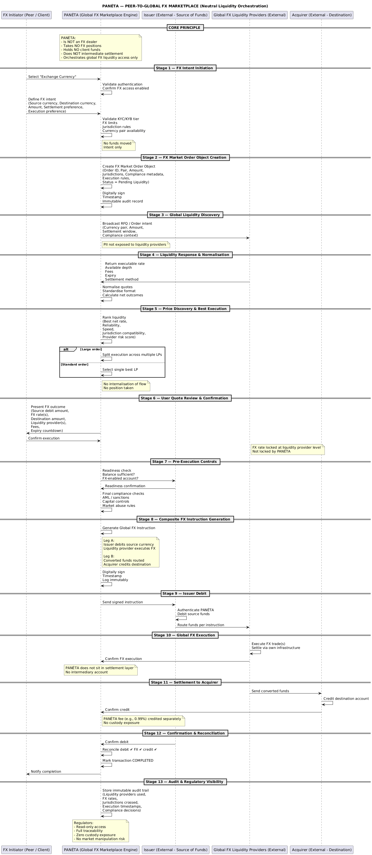

# Whole system Erd

# 1.SYSTEM ENTRY — IDENTITY LAYER

### Core Tables (Top Left)

* users
* user_credentials
* devices
* user_sessions
* risk_assessments

### Flow

1. User registers → users
2. Password stored → user_credentials
3. Device registered → devices
4. Login creates → user_sessions
5. Risk engine updates → risk_assessments

This layer controls system access and risk scoring before any money movement is even possible.

Everything else in the ERD depends on users.id.

# 2.INSTITUTION CONNECTIVITY FLOW (Account Aggregation)

### Tables Involved

* institutions
* institution_connections
* consents
* access_tokens
* external_accounts
* external_transactions
* external_asset_holdings

### Flow

User links a bank/wallet:

users  
 ↓  
institution_connections  
 ↓  
consents  
 ↓  
access_tokens  
 ↓  
external_accounts

Then account data populates:

external_accounts  
 ↓  
external_transactions  
 ↓  
external_asset_holdings

Important:

* No balances stored internally
* No custody accounts exist
* Everything is read-only visibility

# 3.SEND MONEY FLOW (CORE PAYMENT ENGINE)

This is the heart of your system.

### Step 1 — User Creates Payment

users  
 ↓  
transaction_intents

This stores:

* Issuer account
* Destination details
* Amount
* FX flag

No money moved yet.

### Step 2 — Compliance

transaction_intents  
 ↓  
compliance_checks

AML, sanctions, limits, capital control.

If failed → flow stops.

### Step 3 — Instruction Generation

transaction_intents  
 ↓  
payment_instructions  
 ↓  
instruction_legs

Local transfer:

* DEBIT leg
* CREDIT leg

Cross-border transfer:

* DEBIT
* FX
* CREDIT

The multi-leg model is very well structured in your ERD.

### Step 4 — FX Layer (If Required)

If fx_required = true:

transaction_intents  
 ↓  
fx_quotes  
 ↓  
fx_executions

OR marketplace path:

fx_market_orders  
 ↓  
liquidity_provider_responses

FX happens externally. You only log execution.

### Step 5 — Final Reconciliation

payment_instructions  
 ↓  
transactions  
 ↓  
audit_logs

When:

* Issuer confirms debit
* FX confirms conversion
* Acquirer confirms credit

Transaction becomes COMPLETED.

No internal ledger exists.  
No stored balance exists.  
Only reconciliation state.

This is zero-custody architecture.

# 4.PAYMENT REQUEST / MERCHANT FLOW

### Tables

* payment_requests
* merchant_payment_requests
* merchants

Flow:

Merchant creates request:

merchants  
 ↓  
merchant_payment_requests

Payer then creates:

transaction_intents  
 ↓  
payment_instructions  
 ↓  
transactions

Merchant settlement always goes to:

external_accounts

Never to PANÉTA.

# 5.FX MARKETPLACE FLOW

### Tables

* fx_market_orders
* liquidity_provider_responses
* fx_quotes

Flow:

User requests currency exchange:

users  
 ↓  
fx_market_orders  
 ↓  
liquidity_provider_responses

Best liquidity selected.  
Then:

payment_instructions  
 ↓  
fx_executions  
 ↓  
transactions

Again:  
No internal FX dealing.  
No position-taking.  
Pure orchestration.

# 6.P2P FX ESCROW FLOW

### Tables

* fx_offers
* fx_offer_matches
* smart_escrow_states

Flow:

User A creates offer:

users  
 ↓  
fx_offers

User B accepts:

fx_offers  
 ↓  
fx_offer_matches

Escrow activates:

fx_offer_matches  
 ↓  
smart_escrow_states

Only when both sides confirmed:

payment_instructions (dual legs)  
 ↓  
transactions

Escrow is logical state only.  
No funds held internally.

# 7.WEALTH MANAGEMENT FLOW

### Tables

* wealth_subscriptions
* portfolios
* portfolio_holdings
* analytics_snapshots
* scenario_simulations
* invoices

Flow:

User subscribes:

users  
 ↓  
wealth_subscriptions  
 ↓  
invoices

Portfolio engine:

users  
 ↓  
portfolios  
 ↓  
portfolio_holdings  
 ↓  
analytics_snapshots  
 ↓  
scenario_simulations

No trade execution.  
No custody.  
Decision support only.

# 8.AUDIT & REGULATORY FLOW

Everything critical writes to:

audit_logs

Access by regulator logged in:

regulator_access_logs

This gives:

* Full traceability
* No shadow settlement
* No custody exposure
* No advice risk

# STRUCTURAL HIERARCHY OF YOUR ERD

Here is the logical dependency tree:

Identity Layer  
 ↓  
Connectivity Layer  
 ↓  
External Accounts  
 ↓  
TransactionIntent  
 ↓  
Compliance  
 ↓  
Instruction Engine  
 ↓  
FX Layer (optional)  
 ↓  
Transaction Finalisation  
 ↓  
Audit Layer

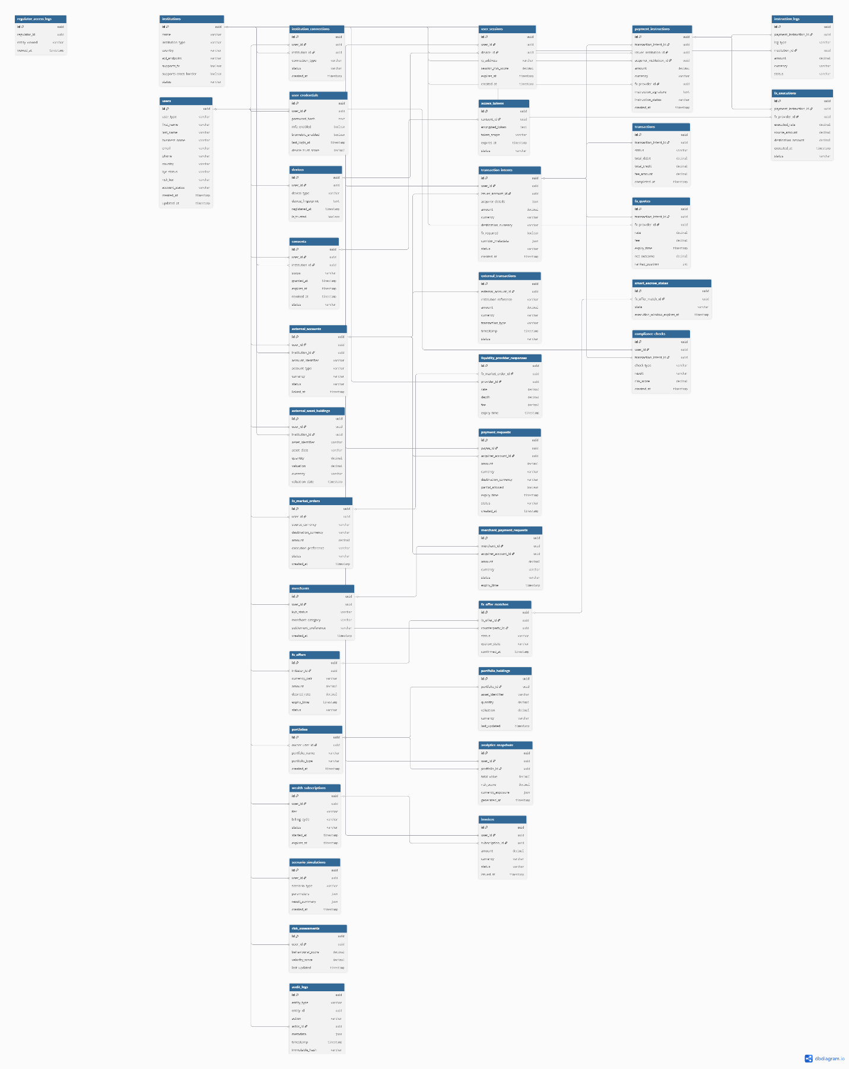

# PANÉTA – Developer & Architecture Completion Document

This document outlines the remaining components required to move PANÉTA from architecture and conceptual design into a fully implementable system. It is intended for software developers, technical leads, and regulators.

## 1. Purpose of This Document

While PANÉTA’s architecture, process flows, ERDs, and sequence diagrams clearly define what the system is and what it must never do (zero-custody, read-only wealth), developers require additional implementation-level clarity. This document fills that gap.

## 2. Service Boundary Definitions (Microservices)

Developers must understand which service owns which responsibility. Each service must be independently deployable and have a clear scope.

* Auth & Identity Service – authentication, token issuance, consent validation
* Payments Orchestration Service – payment requests, instruction generation
* Compliance Service – AML, sanctions, limits, jurisdiction rules
* Routing Service – rail discovery, corridor validation, optimal path selection
* Execution Adapter Service – communication with banks, wallets, card networks
* Pricing & Fee Service – calculation and recording of the 0.99% transaction fee
* Wealth Aggregation Service – read-only account and asset aggregation
* Analytics Service – risk, exposure, forecasting and insights
* Audit & Logging Service – immutable audit trail and regulator logs

## 3. API Contracts (Interfaces)

Each service must expose well-defined APIs. These APIs should be documented using OpenAPI / Swagger and include:

* Endpoint URL and HTTP method
* Authentication and required scope
* Request body schema
* Response body schema
* Error codes and failure scenarios

## 4. State Machines & Lifecycle Management

All payment and wealth processes must follow explicit state transitions to avoid double execution, inconsistent retries, or compliance violations.

Example Payment Instruction States:

* CREATED
* COMPLIANCE_PASSED
* ROUTED
* EXECUTED
* FAILED
* SETTLED

## 5. Event Model (Event-Driven Architecture)

PANÉTA should use events to decouple services and improve scalability.

* PaymentRequestCreated
* CompliancePassed
* InstructionSent
* ExecutionConfirmed
* SettlementConfirmed
* FeeRecorded
* AuditLogged

## 6. Fee Model Rules (0.99%)

The 0.99% fee is PANÉTA’s primary revenue stream and must be implemented carefully:

* Fee is calculated per successful transaction
* Fee is applied AFTER execution confirmation
* Fee is not netted into FX rates
* Fee is stored as metadata only
* PANÉTA never touches transaction funds

## 7. Non-Functional & Regulatory Constraints

These rules must be enforced across the entire system and during code reviews:

* PANÉTA must never store balances or assets
* PANÉTA must never pool or net funds
* All wealth data access is read-only
* Advisors have no execution rights
* All actions must be auditable
* Regulators have read-only system visibility

## 8. Developer Build Order (Runbook)

To ensure a stable implementation, development should follow this order:

1. Auth & Consent Service
2. Payments Request & Instruction Flow
3. Compliance Engine
4. Execution Adapters (with mocks)
5. Audit Logging
6. Pricing & Fee Service
7. Wealth Aggregation & Analytics

# 

# Developer hand-off artifacts

## Service Boundaries (Microservice Map)

**Service boundaries define where logic lives and where it is forbidden, ensuring PANÉTA remains zero-custody, compliant, and scalable.**

Below is the **correct microservice map** for PANÉTA, aligned with **zero-custody and read-only wealth**.

## Auth & Identity Service

**Owns:**

* Login
* Tokens
* MFA
* Session management

**Must NEVER:**

* Know about payments
* Know about balances
* Talk to banks

## 2. Consent & Access Service

**Owns:**

* User consent
* Scope (payments / wealth)
* Advisor permissions

**Must NEVER:**

* Execute payments
* Fetch wealth data directly

## 3. Payments Orchestration Service

**Owns:**

* Payment requests
* Instruction generation
* Payment state machine

**Must NEVER:**

* Move money
* Debit accounts
* Hold balances

## 4. Compliance Service

**Owns:**

* AML / PEP / sanctions
* Limits
* Jurisdiction rules

**Must NEVER:**

* Execute instructions
* Modify payment data

## 5. Routing & Corridor Service

**Owns:**

* Rail discovery
* Corridor validation
* Best-path selection

**Must NEVER:**

* Apply fees
* Perform execution

## 6. Execution Adapter Service

**Owns:**

* Talking to banks
* Talking to wallets
* Receiving execution status

**Must NEVER:**

* Generate instructions
* Apply fees
* Store balances

## 7. Pricing & Fee Service (0.99%)

**Owns:**

* Fee calculation
* Fee recording

**Must NEVER:**

* Touch funds
* Alter FX rates
* Execute transactions

## 8. Wealth Aggregation Service (Read-Only)

**Owns:**

* Fetching balances
* Fetching holdings
* Normalisation

**Must NEVER:**

* Execute trades
* Modify accounts

## 9. Wealth Analytics Service

**Owns:**

* Risk analysis
* Exposure analysis
* Forecasts

**Must NEVER:**

* Fetch data directly from banks
* Execute investments

## Audit & Logging Service

**Owns:**

* Immutable logs
* Regulatory access

**Must NEVER:**

* Change business state
* Execute logic

## 5.How Services Talk to Each Other

They communicate via:

* **Events** (preferred)
* **Strict APIs**

Example:

Payments Orchestration

→ emits InstructionCreated

Compliance Service listens

→ emits CompliancePassed

Routing Service listens

→ emits RouteSelected

Execution Adapter listens

No direct database sharing.

## 6.Microservice Map

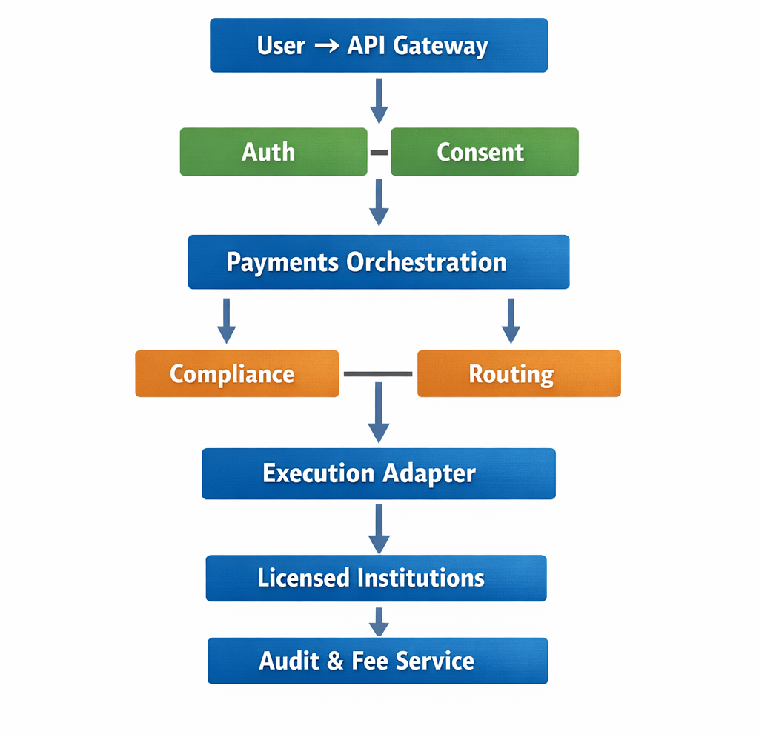

## 7 One-Sentence

A **service responsibility list**, for example:

Auth & Identity Service

- authenticateUser()

- issueAccessToken()

- validateConsent()

Payments Orchestration Service

- createPaymentRequest()

- generatePaymentInstruction()

- selectRoute()

Compliance Service

- runAML()

- runPEP()

- enforceLimits()

Routing Service

- discoverRails()

- selectOptimalRoute()

Execution Adapter Service

- sendInstructionToBank()

- receiveSettlementStatus()

Pricing Service

- calculateFee(0.99%)

- recordFeeMetadata()

Wealth Aggregation Service

- linkExternalAccount()

- fetchReadOnlyBalances()

- normalizeData()

Analytics Service

- computeRisk()

- computeFXExposure()

Audit Service

- writeImmutableLog()

This is **non-negotiable** for developers.

## API Contracts (Request / Response Definitions)

The PANÉTA architecture, system diagrams, process flows, sequence diagrams, and ERDs clearly define **what happens within the platform** and **which components are involved at each stage**. However, they do not yet define **how systems, services, and external clients communicate at an interface level**.

In other words, PANÉTA currently specifies behaviour and responsibility, but not the **technical language through which those behaviours are invoked and enforced**.

### Why This Matters

Software systems do not execute diagrams they execute **API calls**.

Without clearly defined API contracts:

* Developers must guess request and response structures
* Different teams may implement incompatible payloads
* Security and authorization scopes may be applied inconsistently
* Compliance checks may be skipped or incorrectly triggered
* Zero-custody guarantees may be unintentionally violated
* Fee application logic may become inconsistent or duplicated
* Integrations with banks, wallets, and third-party providers may break unexpectedly

For a regulated, zero-custody financial platform such as PANÉTA, **interface ambiguity represents both a technical risk and a regulatory risk**.

API contracts eliminate this ambiguity by making communication rules **explicit, enforceable, and testable**.

This define **explicit API contracts at an OpenAPI (Swagger) level** for all externally exposed and internally consumed endpoints.

These contracts become the **authoritative source of truth** for how:

* Clients interact with PANÉTA
* Internal microservices communicate
* External institutions integrate safely

At a minimum, the following core APIs must be formally specified.

### Core Payments API Endpoints

POST /payments/requests

POST /payments/instructions

POST /payments/execute

GET /payments/status/{id}

These endpoints support:

* Payment initiation and intent capture
* Generation of payment instructions
* Orchestration of licensed execution
* End-to-end transaction status tracking

API contracts for these endpoints must explicitly enforce that:

* PANÉTA generates and routes **instructions only**
* Execution occurs exclusively at licensed financial institutions
* PANÉTA never holds, pools, or moves funds
* Fees are applied only after successful execution

### Core Wealth (Read-Only) API Endpoints

GET /wealth/accounts

GET /wealth/holdings

GET /wealth/analytics

These endpoints support:

* Aggregated account visibility
* Asset and balance snapshots
* Portfolio, risk, and exposure analytics

API contracts for wealth endpoints must strictly enforce:

* Read-only access
* No execution, trading, or modification capability
* Advisor-safe permissions and scopes
* Snapshot-based, auditable data access

### Required Elements of Every API Contract

Each API endpoint in PANÉTA must explicitly define the following elements.

#### 1. Request Body Definition

* Required fields
* Optional fields
* Data types
* Validation rules

This prevents malformed data, hidden fields, and payloads that could imply custody or execution.

#### 2. Response Body Definition

* Returned fields
* Reference identifiers (request ID, instruction ID)
* Status indicators

Responses must be **informational**, confirming state and outcome rather than implying ownership of funds or assets.

#### 3. Error Cases

* Standardized error codes
* Clear error messages
* Explicit failure reasons (compliance failure, invalid consent, routing unavailable)

This enables predictable retries, safe failure handling, and complete auditability.

#### 4. Authentication and Authorization Scope

Each endpoint must declare:

* Whether authentication is required
* Which roles may access it (Individual, Business, Advisor)
* Which scope is required (payments, wealth)

This ensures that:

* Advisors cannot initiate payments
* Wealth endpoints cannot be used for execution
* Unauthorized access is blocked by default

### Impact on Implementation Consistency

By defining API contracts:

* All teams implement the same interfaces
* Business rules are enforced at the boundary, not in scattered logic
* Compliance and zero-custody principles are protected by design
* Future integrations can be added without breaking existing behaviour
* Testing, monitoring, and auditing become straightforward

### Summary

API contracts transform PANÉTA from a conceptual architecture into a **buildable, enforceable, and regulator-safe system**.

They define **how systems talk**, **what data is allowed**, and **what actions are forbidden**, ensuring consistency across development teams while protecting PANÉTA’s regulatory, operational, and commercial integrity.

## 3. State Machines (CRITICAL)

The PANÉTA architecture, process flows, and sequence diagrams clearly illustrate **the order of operations** within payment orchestration and wealth management. However, these flows currently **imply state changes rather than explicitly defining them**.

In the absence of formally defined state machines, the system relies on implicit assumptions about transaction progression. This creates ambiguity in how the system should behave during failures, retries, partial executions, or external timeouts.

In real-world financial systems, **payments do not always succeed**. Network failures, institution downtime, compliance rejections, duplicate requests, and delayed confirmations are common.

If states are not explicitly defined:

* Retries may cause **double execution**
* A payment may be marked successful without settlement
* Fees may be charged more than once
* Reversals may be applied incorrectly
* Audit trails may become inconsistent

For a zero-custody platform like PANÉTA, **state ambiguity is a direct financial and regulatory risk**.

Explicit state machines ensure that:

* Every object has a single, valid state at any point in time
* Transitions occur only in permitted sequences
* Retries are idempotent
* Fees are applied once and only once
* Failures are handled predictably and audibly

This defines **explicit state machines** for all key transactional entities.  
These state machines must be enforced in code and referenced consistently across services.

### Payment_Request State Machine

The Payment_Request represents **user intent**.

**Required States:**

CREATED → CONFIRMED → CANCELLED

**State Definitions:**

* **CREATED**  
  The user has initiated a payment request, but it has not yet been confirmed.
* **CONFIRMED**  
  The user has approved the request and it is eligible for instruction generation.
* **CANCELLED**  
  The request has been withdrawn or invalidated prior to instruction issuance.

A cancelled request must never generate a payment instruction.

### Payment_Instruction State Machine

The Payment_Instruction represents a **formal, compliant instruction** generated by PANÉTA.

**Required States:**

CREATED → COMPLIANCE_PASSED → SENT → EXECUTED → FAILED

**State Definitions:**

* **CREATED**  
  Instruction generated but not yet validated.
* **COMPLIANCE_PASSED**  
  All AML, sanctions, and policy checks have succeeded.
* **SENT**  
  Instruction has been routed to the licensed execution adapter.
* **EXECUTED**  
  Licensed institution has confirmed execution.
* **FAILED**  
  Instruction could not be executed or was rejected.

An instruction in FAILED state must never be retried automatically without explicit rules.

### Execution State Machine

The Execution entity reflects **external settlement status**, controlled by licensed institutions.

**Required States:**

PENDING → SUCCESS → REVERSED

**State Definitions:**

* **PENDING**  
  Execution request has been sent but not yet confirmed.
* **SUCCESS**  
  Funds have been successfully settled by the institution.
* **REVERSED**  
  A completed execution has been reversed where permitted.

Execution state changes originate **outside PANÉTA** and are reported back.

### Benefits of Explicit State Machines

By defining and enforcing state machines, PANÉTA:

* Prevents double execution
* Prevents phantom or duplicate fee charging
* Enables safe retries and reversals
* Ensures audit logs reflect true system state
* Aligns with banking-grade transaction processing standards

**Explicit state machines are mandatory for safe, scalable payment orchestration.**

## 4. Event Model (Async Backbone)

This defines a **canonical event catalogue** that all services adhere to.  
Each event must represent a **meaningful business state change**, not a technical implementation detail.

### Canonical Event List

The following events must be formally defined and documented:

UserConsented

PaymentRequestCreated

CompliancePassed

InstructionRouted

InstructionExecuted

SettlementConfirmed

FeeRecorded

AuditLogged

### Event Definitions (Conceptual)

* **UserConsented**  
  Emitted when a user grants explicit consent for a payment or wealth action.
* **PaymentRequestCreated**  
  Emitted when a valid payment request is registered.
* **CompliancePassed**  
  Emitted when all compliance checks succeed.
* **InstructionRouted**  
  Emitted when an instruction is successfully routed to an execution adapter.
* **InstructionExecuted**  
  Emitted when a licensed institution confirms execution.
* **SettlementConfirmed**  
  Emitted when final settlement confirmation is received.
* **FeeRecorded**  
  Emitted when the 0.99% fee is calculated and recorded (post-execution).
* **AuditLogged**  
  Emitted when an immutable audit record is written.

.

## 5. Fee Application Rule (0.99%) — Formalized

The PANÉTA platform has clearly stated that it charges a **0.99% transaction fee** as its primary revenue mechanism. However, this statement alone is **insufficient for implementation and regulatory assurance**.

In regulated financial systems, **fee handling must never be implied**. It must be explicitly defined in rules that developers can implement and auditors can verify.

### Why This Matters

Fees are **legally and regulatorily sensitive** for several reasons:

* Incorrect fee timing can imply **unauthorised fund handling**
* Netting fees into settlement amounts can imply **custody or intermediation**
* Bundling fees into FX rates can imply **hidden spreads**
* Duplicate fee application can result in **consumer harm**
* Ambiguous fee logic creates **audit and compliance risk**

For PANÉTA, which operates under a **zero-custody orchestration model**, fee application must be implemented in a way that **cannot be misconstrued as fund control or settlement participation**.

### Fee Design Principle

PANÉTA’s fee model is designed to ensure that:

* PANÉTA earns revenue **without touching transaction funds**
* Fees are **transparent, traceable, and auditable**
* Fee logic is **separate from execution logic**
* Fee application does **not alter transaction outcomes**

### Explicit Fee Rules (Mandatory)

The following rules **must be enforced in code and configuration**.

#### Fee Characteristics

The PANÉTA fee:

* **Is calculated after execution**
* **Is applied per successful transaction**
* **Is derived from the executed transaction amount**
* **Is recorded as metadata**
* **Does not interfere with settlement flows**

#### Fee Timing Rule

The fee must be calculated **only after a licensed institution confirms successful execution**.

* No fee may be calculated or recorded for:
  + Failed instructions
  + Cancelled requests
  + Rejected compliance checks
* No fee may be applied at instruction creation time
* No fee may be applied at routing time

This ensures PANÉTA does not benefit from unsuccessful or unexecuted transactions.

#### Fee Calculation Rule

The fee amount is calculated using the following formula:

fee_amount = executed_amount × 0.0099

Where:

* executed_amount is the final amount confirmed by the licensed institution
* 0.0099 represents the fixed 0.99% fee rate

The fee calculation must be **deterministic and idempotent**.

#### Fee Storage Rule

The fee must be:

* Stored as a **separate metadata record**
* Linked to the corresponding payment instruction or execution record
* Included in audit logs and reporting views

The fee must **not** be:

* Stored as a balance
* Stored as a wallet amount
* Stored as a pooled value
* Treated as settlement funds

### Explicit Prohibitions (Must NOT Happen)

The PANÉTA fee **must not** be:

* Netted into the transaction amount
* Deducted from the settlement flow
* Bundled into FX rates or exchange spreads
* Taken before settlement confirmation
* Applied more than once per transaction

These prohibitions are critical to maintaining PANÉTA’s **non-custodial and non-intermediary status**.

### Relationship to Zero-Custody Model

The fee model is deliberately designed so that:

* Funds move **only between licensed institutions**
* PANÉTA observes execution but does not participate in settlement
* Fee calculation is informational and contractual, not transactional

This ensures that PANÉTA:

* Is not classified as a payment processor
* Is not classified as a money transmitter
* Does not require custody-related licensing

### Audit and Regulatory Implications

The explicit fee rules enable:

* Clear audit trails for each transaction
* Verification that fees are applied correctly
* Proof that fees are not hidden or manipulated
* Transparent reporting to regulators and partners

Regulators can verify:

* When a fee was applied
* Why it was applied
* That it followed execution
* That no custody occurred

### Summary

The 0.99% fee is a **core commercial component** of the PANÉTA platform and must be implemented with **absolute clarity and precision**.

By formalising fee application rules:

* Developers can implement fee logic safely
* Auditors can verify compliance easily
* Regulators can confirm zero-custody alignment
* PANÉTA’s revenue model remains transparent and defensible

**This fee model must be written, enforced, and audited never implied.**

## 6. Non-Functional Constraints (Guardrails)

### What Is Missing

While PANÉTA’s architecture, flows, ERDs, and APIs define how the system works, they do not yet explicitly define **what the system must never do**.

In regulated financial systems, **non-functional constraints** act as **hard guardrails** that developers, reviewers, and auditors rely on to ensure that implementation decisions do not violate legal, regulatory, or architectural principles.

What is currently missing is a **clear, written set of non-negotiable rules** that apply across all services, environments, and code changes.

### Why This Matters

Non-functional constraints are not optional design preferences they are **legal and regulatory protections**.

Without explicit guardrails:

* Developers may introduce “temporary” shortcuts that imply custody
* Refactoring may accidentally merge execution and orchestration logic
* Logging or encryption may be skipped under pressure
* Advisors or internal users may gain unintended privileges
* Regulators may question PANÉTA’s non-custodial status

For PANÉTA, which operates under a **zero-custody, read-only wealth, instruction-only payment model**, these constraints are what **protect the company legally and operationally**.

### Purpose of Non-Functional Constraints

The purpose of these constraints is to:

* Enforce zero-custody by design
* Prevent role and responsibility leakage
* Ensure consistent compliance across teams
* Provide clear criteria for code reviews
* Support regulator assurance and audits

These rules apply to:

* All services
* All APIs
* All environments (development, staging, production)
* All future extensions of the platform

### Mandatory Guardrails (MUST / MUST NOT)

The following rules **must be enforced in code, configuration, reviews, and audits**.

### PANÉTA MUST NOT

The PANÉTA platform **must never**:

* **Store balances**  
  PANÉTA must not maintain account balances, wallet balances, or asset balances of any kind.
* **Pool funds**  
  PANÉTA must not aggregate, net, or temporarily hold funds belonging to users or institutions.
* **Execute trades or settlements**  
  PANÉTA must not debit, credit, settle, convert, or rebalance funds or assets.
* **Act as a custodian or intermediary**  
  PANÉTA must not be positioned as a holder or controller of money or investments.
* **Modify external financial data**  
  PANÉTA must not alter balances, holdings, or transactions at licensed institutions.
* **Bypass compliance or consent checks**  
  No service may skip or override compliance and consent enforcement.

### PANÉTA MUST

The PANÉTA platform **must always**:

* **Log all payment instructions and state changes**  
  Every instruction, status update, and execution outcome must be immutably logged.
* **Encrypt all tokens and sensitive data**  
  Authentication tokens, consent references, and identifiers must be encrypted at rest and in transit.
* **Enforce role-based access control**  
  Permissions must be strictly enforced for Individuals, Businesses, Advisors, and Regulators.
* **Provide regulator read-only access**  
  Regulators must be able to view audit logs, reports, and compliance evidence without execution rights.
* **Separate orchestration from execution**  
  Instruction generation and execution must always remain in separate services and domains.
* **Enforce read-only wealth access**  
  All wealth management endpoints must be read-only and advisor-safe by design.

### Enforcement in Development and Reviews

These guardrails must be treated as **hard acceptance criteria**:

* Code reviews must explicitly verify compliance with MUST / MUST NOT rules
* Any change that violates a guardrail must be rejected
* Automated tests should validate non-functional constraints where possible
* Security and compliance reviews must reference this section directly

**No feature or business requirement overrides these constraints.**

### Regulatory and Audit Implications

Explicit non-functional constraints allow PANÉTA to demonstrate that:

* Custody is structurally impossible
* Execution responsibility remains with licensed institutions
* Data access is controlled and auditable
* Compliance is enforced systematically, not informally

These guardrails provide regulators with **clear, verifiable assurances** and reduce interpretation risk.

### Summary

Non-functional constraints are the **legal and architectural backbone** of the PANÉTA platform.

By explicitly defining what the system **must** and **must not** do:

* Developers are protected from accidental violations
* Code reviews become objective and enforceable
* Regulatory risk is reduced
* PANÉTA’s zero-custody and read-only principles are preserved at scale

**These guardrails must be written, enforced, and treated as non-negotiable**

.

## 7. Developer Runbook (How to Start)

While PANÉTA’s architecture, service boundaries, API contracts, state machines, and event models define **what must be built**, they do not yet define **the order in which it should be built**.

Without an explicit developer runbook, development teams will inevitably ask:

“What do we build first?”

In the absence of a defined build order:

* Teams may start with execution before orchestration
* Fee logic may be implemented too early or incorrectly
* Audit logging may be added after the fact
* Compliance enforcement may be bolted on instead of embedded
* Wealth aggregation may accidentally gain execution capabilities

What is missing is a **clear, authoritative build sequence** that aligns implementation with PANÉTA’s zero-custody, compliance-first design.

### Why This Matters

PANÉTA is not a simple CRUD application. It is a **regulated, event-driven financial orchestration platform**.

If development does not follow a controlled order:

* Core invariants (zero custody, read-only wealth) may be violated unintentionally
* Services may become tightly coupled
* Refactoring costs increase dramatically
* Compliance gaps may only be discovered late
* Regulatory review becomes harder

A developer runbook ensures that:

* Foundational services are built first
* Risky capabilities are introduced last
* Each layer is validated before the next is added
* The system grows in a controlled, auditable manner

### Required Developer Build Order

The following build order **must be followed** to ensure a stable, compliant implementation.

### 1. Auth & Consent Service

**Purpose:** Establish identity, access control, and consent enforcement.

This service must be implemented first because **all other services depend on it**.

Scope includes:

* Authentication (users, businesses, advisors)
* Token issuance and validation
* Consent capture and validation
* Role and scope enforcement

No payment, wealth, or execution logic may be implemented before this service is operational.

### 2. Payment Request → Instruction Flow

**Purpose:** Capture user intent and generate payment instructions without execution.

This phase establishes:

* Payment request creation
* Instruction generation
* Core payment state machines
* Event emission (e.g., PaymentRequestCreated)

At this stage:

* No money moves
* No banks are called
* No fees are applied

### 3. Compliance Checks

**Purpose:** Enforce AML, sanctions, limits, and jurisdiction rules.

This service must be added **before any execution capability exists**.

Scope includes:

* Pre-transaction checks
* Rule evaluation
* Approval or rejection events

Any instruction that does not pass compliance must never reach execution.

### 4. Execution Adapters (Mock First)

**Purpose:** Integrate with licensed institutions safely.

Execution adapters must be:

* Implemented using mocks initially
* Event-driven
* Isolated from orchestration logic

This allows:

* End-to-end flow testing
* Failure simulation
* Retry logic validation

Real bank or wallet integrations must only be connected after mocks are stable.

### 5. Audit Logging

**Purpose:** Ensure full traceability and regulatory readiness.

Audit logging must be implemented **before production execution**.

Scope includes:

* Instruction logs
* State transitions
* Execution confirmations
* Error and failure events

If an action is not logged, it is considered invalid.

### 6. Fee Service (0.99%)

**Purpose:** Implement PANÉTA’s revenue model safely.

The fee service must be added **after execution and audit logging**.

Scope includes:

* Fee calculation post-execution
* Fee metadata storage
* Fee-related events (FeeRecorded)

Fees must never affect execution or settlement logic.

### 7. Wealth Aggregation (Read-Only)

**Purpose:** Add financial visibility and analytics.

This service must be implemented **last** to avoid accidental execution capabilities.

Scope includes:

* Account aggregation
* Holdings aggregation
* Analytics and insights

Strict rules:

* Read-only access only
* No execution, trading, or modification
* Advisor-safe permissions enforced

Wealth services must never call payment execution APIs.

### Development Principles Enforced by This Runbook

This build order ensures that:

* Security and consent come first
* Orchestration is built before execution
* Compliance is embedded, not added later
* Auditability is guaranteed
* Revenue logic is safe and transparent
* Wealth management remains advisory and read-only

### Use of This Runbook

This runbook must be:

* Referenced during developer onboarding
* Used during sprint planning
* Enforced during code reviews
* Cited during regulatory or audit reviews

No feature or shortcut should override this sequence.

### Summary

The Developer Runbook provides a **controlled, compliant path from architecture to production**.

By explicitly defining **what to build and in what order**, PANÉTA:

* Avoids implementation chaos
* Protects its zero-custody model
* Reduces regulatory risk
* Enables predictable, scalable delivery

**This runbook turns PANÉTA from a design into a buildable system.**

# 